 | 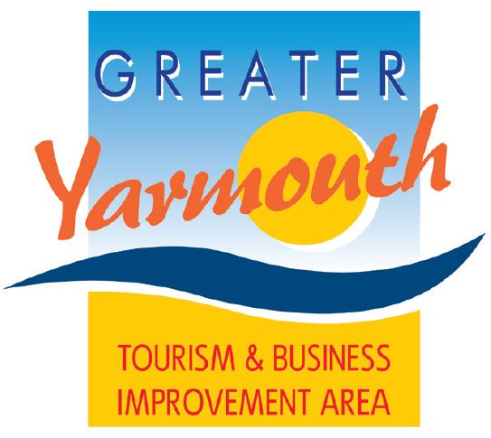 | Date as postmark
ANNUAL TOURISM & BUSINESS AWARDS 2019

Recognising successful businesses and business people is an important part of enhancing the profile of the Borough as a place to live, visit and do business. The original awards back in 1995 were based around 'investment in tourism' and 'grading achievement awards'.

In 2017 the awards were given a comprehensive overhaul that introduced a new set of awards based on themes rather that business sectors.

Attached is the nomination form showing all categories and giving more details about each of the categories. The awards are open to all GYTABIA levy payers and you are able to self-nominate or nominate your peers. You can only make one nomination per category but you are able to nominate in all categories and please don’t forget to explain why you feel your nomination deserves the award.

When you have completed your nomination form please return to us either via email or post by the 15th February 2019 and the winners will be announced at our annual Tourism & Business Awards to be held at the Town Hall, Great Yarmouth on Tuesday 27th March 2019. Details of how to obtain tickets are also enclosed.

Nomination Return Information:
Via email to Karen Youngs at karen@gyta.com
Or
via post to : Karen Youngs, GYTABIA, c/o Marina Centre, Great Yarmouth, NR30 2ER

If you require any further information on the awards please do not hesitate to contact Karen on Great Yarmouth 01493 331 532. In the meantime we look forward to receiving your nominations.

Best regards
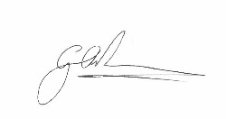
Gareth Brown
Chairman
Greater Yarmouth Tourism & Business Improvement Area Ltd

