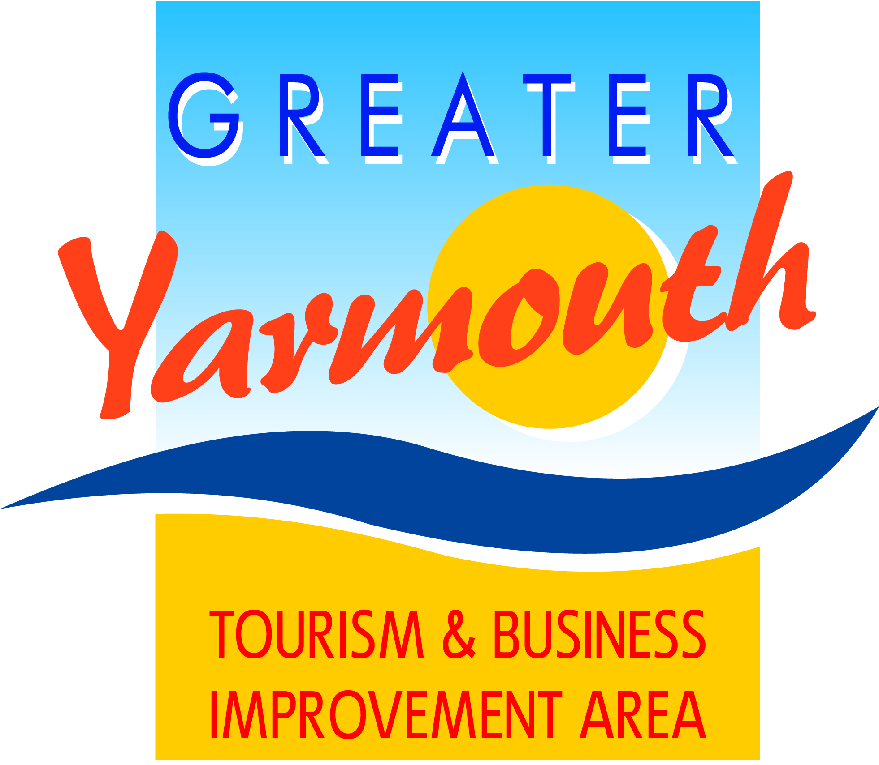

ANNUAL
TOURISM & BUSINESS AWARDS LUNCHEON
12 noon for 12.30pm
Tuesday 24th March 2020 – Assembly Room
Town Hall, Great Yarmouth

I/We would like to attend the Annual Tourism Awards Lunch
Please send me ……...tickets @ £20.00 each
Please book me a table of 10 for £180 (tick if applicable)
No. | NAME | Vegetarian or other dietary requirements
1
2
3
4
5
6
7
8
9
10

Name
(for correspondence)
Business name
(if applicable)
Preferred correspondence Address
Email Address

Telephone number

Please return this form with your cheque to:
GYTABIA, c/o Maritime House, 25 Marine Parade, Great Yarmouth, NR30 2EN
Or
pay via BACS to GYTABIA at Lloyds Bank 30-99-97 Account No. 00905385

