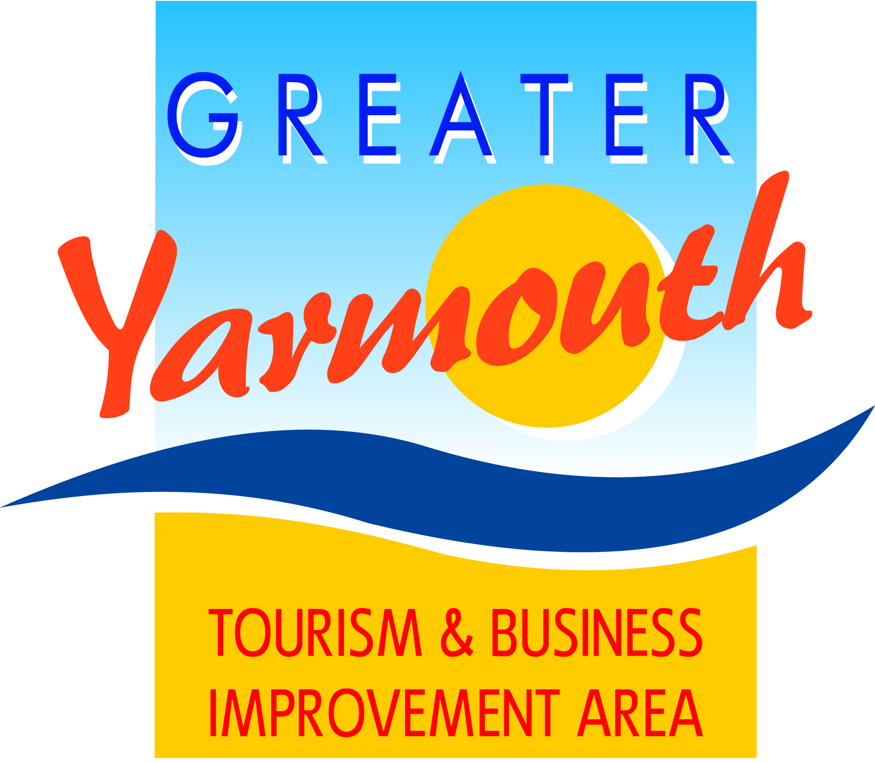

BID BOARD
10th September 2014
Maritime House

Present : David Marsh
Michael Jeal
Ken Sims
Peter Jay
Malcolm Bird
Tony Smith
Gareth brown
Albert Jones
Kevin Huggins
Alan Carr
Karen Youngs

1. How's Business?

Good to reasonable; current and future school holiday issues.

2. Review of the BID
-last informal meeting as a task group before becoming a full board
- communication with 1200 businesses.
- copies of letters to businesses circulated to all members.
- reply card circulated to members, asking to sign up for no more than 3 groups.
- Project appraisal form.
- GYBC about to send out the invoices - within the next 3 weeks. - a letter will be included in with the invoice.

3. Constitution
- confirmed new name as Greater Yarmouth Tourism & Business Improvement Area
- agreed to adopt the constitution noting the points in DMs report. And deleting the word 'cabinet' from 2h - 21.1.3
a) Agreed no substitute directors
b) Chairman always a private director – Michael Jeal didn’t agree with this and asked to leave it as ‘may’

4. Live Projects
4.1 Fireworks: agreed to 6 dates – 22/7/15 to 26/8/15 and £1500 budget per show approved.

4.2 Maritime Festival 2015: agreed to continue to under-write to £10,000

5. Protocols
-agreed to send both form and appraisal questions to project applicants.

6. Sector Groups
- terms of reference needed

7. Meetings Programme
- Agreed

8. Any Other Business

8.1 Deregulation of School Holidays
Moving 2 summer holiday weeks to February and October.
Meeting planned at 11am next Tuesday 16th at the Pleasure Beach.
Limited Govt advice . DM understood that schools can choose 4 weeks from a 12-week period.

8.2 invite TCP Manager to attend Board meetings and the tourism retail sector group but to have no vote.

