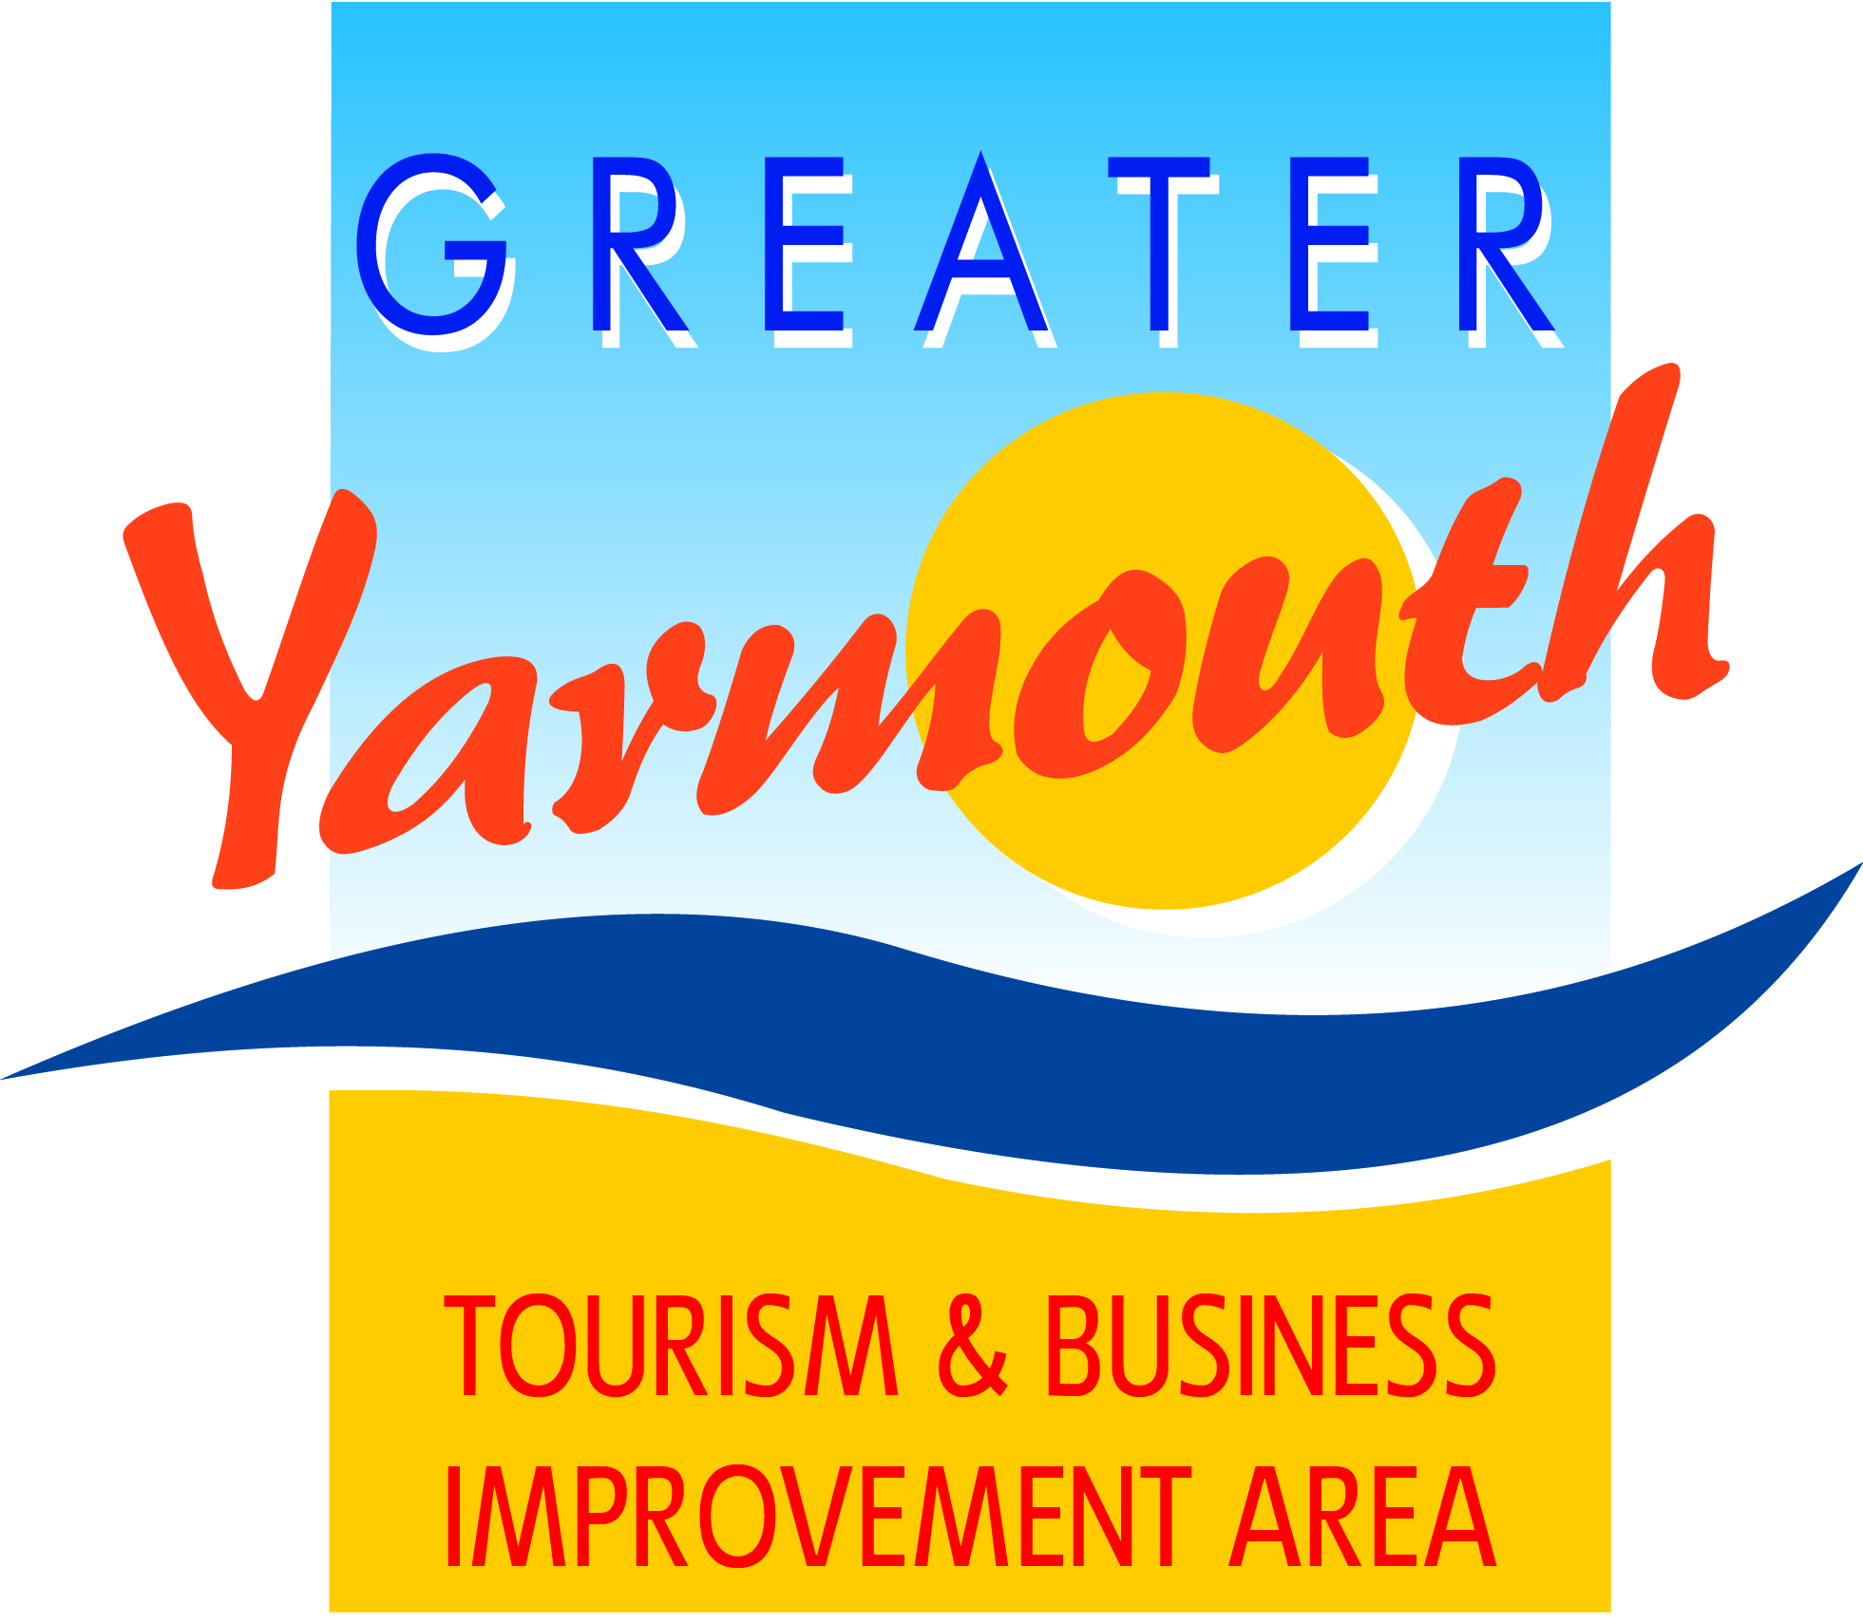

Minutes of the BID BOARD held on 29th January 2015 at 10.30am
At Maritime House, Great Yarmouth
Present :
David Marsh | Alan Carr | Gareth Brown
Terri Harris | Amy Woodyatt | Ken Sims
Kirsty Burn | James Gray | Lyndon Bevan
Jane Reynolds | Cllr Brian Walker | Cllr Michael Jeal
Jonathan Newman | Tony Smith | Peter Jay
Cllr Bert Collins (Hon Pres) | Cllr Sue Hacon | Karen Youngs
Oliver Hurren | Kevin Huggins | Toni Reeve
Cllr Barry Coleman | Linda Dyble | Albert Jones

1 |  | Welcome
 | 1.1 | Welcome was given to Cllr Barry Coleman as the new representative from the Conservative party and Cllr Sue Hacon from UKIP
2 |  | Apologies for absence
 | 2.1 | Apologies were received from Malcolm Bird and Andrew Bowyer.
 | 2.2 | It was noted that a celebration of the life of Brian Potter was due to be held at Potters resort on Wednesday 4th February. If anyone wanted to attend to register on the Potters website.
3 |  | GYTBIA Board of 26th November notes and matters arising
 | 3.1 | The minutes were agreed as a true and accurate record.
 | 3.2 | The Brochure & BID company launch were very successful and thanks were given to the Boathouse for their generous sponsorship of the event.
 | 3.3 | Apologies were given for the fact that the meeting was deferred this was due to the independent report pn the BID commissioned by GYBC (see BID Update below).
4 |  | Matters Arising
 |  | There were no matters arising
5 |  | BID Update
 | 5.1 | As a result of a meeting held on Regent Road by business owners with Cllr Jeal, Cllr Wainwright and David Marsh in attendance and a subsequent appeal from the group, GYBC had commissioned a report to investigate that all due process had been carried out in respect of the BID. GYBC concluded that they were satisfied that all protocols had been achieved and the collection of the levy would re-commence Friday 30th January.
 | 5.2 | David Marsh gave thanks to Alan Carr, Kirsty Burn & Karen Youngs for their hard work on the BID
 | 5.3 | A further meeting will be held with 6 of the main protagonists at the Town Hall. David Marsh, Cllr Wainwright, Gordon Mitchell and Cllr Jeal and Alan Carr invited to attend. Other directors offered their presence if required.
 | 5.4 | David Marsh agreed to draft a press release explaining the progress on the BID and BID projects and asked if the Board were happy to put their names to it. All agreed.
 | 5.5 | Tony Smith gave thanks to David Marsh for all his hard work on the BID
 | 5.6 | A budget paper was handed out for the period 1st October 2014 to 30th September 2015. It was noted that all future budget years will be from the 1st October through to 30th September
 | 5.7 | Noted that around 34% of the levy collection had been received within the first 30/40 days however due to recent uncertainties and the coverage in the local press it was noted that the rate of collection had slowed down.
 | 5.8 | It was noted that we continue to receive appeals against inclusion in the BID. Members received and accepted the appeals process.
 | 5.9 | Agreed to review all business category codes that are currently included in the BID in 5 years time
6. |  | Constitutional Matters
 | 6.1 | Members discussed a Members’ Charter which subject to minor amendments was agreed and is attached at Appendix A.
 | 6.3 | The Chairman proposed, Toni Reeve seconded and all agreed to co-opt John Potter on to the BID Board..
7 |  | Marketing & Events Bid Projects
 | 7.1 | An updated status list of events, marketing & small projects was noted and approved by the Board
 | 7.2 | Members received and agreed with the specification to appoint a new marketing/PR position.
8 |  | Facilities/Maintenance & Access (FMA)
 | 8.1 | The Chairman introduced the methodology to prioritise projects submitted with the FMA category. All projects had been scored against a set of 15 strategic priorities.
 | 8.2 | Following a brief introduction to each project Board members were invited to score each project from ‘5’ – top priority to ‘1’ – low priority.
 | 8.3 | The final ranking would be determined by multiplying the total strategic score with the Board priority score.
 | 8.4 | It was agreed to defer projects 3.03 Walk of Fame and 3.04 Upgraded seafront gardens and to approve radio/CCTV application.
 | 8.5 | Outcome of the scoring attached at Appendix B
9 |  | Output Groups
 | 9.1 | The terms of reference for the output groups were shown to the Board (attached) It was agreed that the terms were a broad reference and may need tweaking for each group.
 | 9.1 | Agreed that Ken Sims to chair Marketing, Lyndon Bevan to chair the Events Group and Gareth Brown to chair FMA group
10 |  | Communications Strategy
 | 10.1 | The Board received and approved the communications strategy.
11 |  | Annual Tourism & Business Lunch/Awards
 | 11.1 | The change of date to the 21st May was agreed by the Board. Agreed to review the date for 2016.
12 |  | Annual Meetings Programme
 | 12.1 | The Board noted the annual meetings calendar.
13 |  | Items for next meeting
 | 13.1 | Discussion about necessity of Board to discuss all planning issues.
 | 13.2 | It was agreed to defer the item on representation on outside organisations
14 |  | AOB
 | 14.1 | Noted that the college are keen to put forward work experience students for building & gardening projects.
 | 14.2 | PIP’s licence has been extended from the 1st April 2015 to the 31st October 2015. GYTABIA own the columns and will work with H2 Creative Media to provide the service. It is anticipated that the new tender documents would be published shortly by GYBC.
 | 14.3 | The Board were informed that the Salisbury Road toilets will be closed as from the 31st March 2015. A number of public toilets in the borough will have their funding withdrawn which includes Alpha Road and Quayside in Gorleston
 | 14.4 | The Board were informed that car park charges would be increasing by 50p for a half and £1 for a full day. Compared to other resorts this is not as expensive.
 | 14.5 | Board informed that the Maritime House building maybe closed for tourism use. It was generally agreed that the tourism team were much better placed on the seafront.

