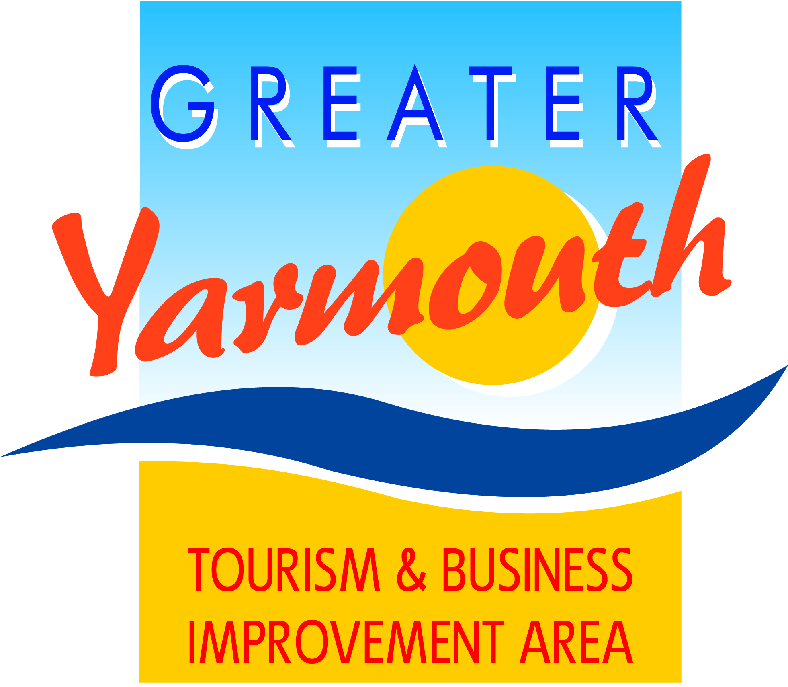

Minutes of the meeting of the
BOARD of the GREATER YARMOUTH TOURISM AND BUSINESS IMPROVEMENT AREA LTD
held on THURSDAY 16th July 2015
at The Imperial Hotel, North Drive

Present:
David Marsh | Amy Greenwood | Toni Reeve
Linda Dyble | James Gray | John Potter
Cllr Barry Coleman | Oliver Hurren | Albert Jones
Asa Morrison | Jane Reynolds | Malcolm Bird
Ken Sims | Bert Collins (Hon President) | Karen Youngs
Terri Harris | Lyndon Bevan | Kevin Huggins
Tony Smith | Andrew Bowyer | Peter Jay
Gareth Brown | Cllr Michael Jeal | Jonathan Newman
Kirsty Burn

40 |  | APOLOGIES FOR ABSENCE
 | 40.1 | Apologies were received from Alan Carr
41 |  | INTRODUCTIONS
 | 41.1 | Asa Morrison was introduced to the Board as a GYTABIA member of staff working 1 day a week to work on core projects.
42 |  | MINUTES OF THE PREVIOUS MEETINGS
 | 42.1 | The minutes of the BID Board meeting on 14th May 2015 were approved as a true and accurate record.
43 |  | MATTERS ARISING FROM THE MINUTES
 | 43.1 | Ref 17.2 Rent of Maritime House Ground Floor
 |  | Plans to convert the upper two floors have not been pursued. GYTABIA will be making a small contribution to running costs in order to maintain space for BID staff and BID meetings
 | 43.2 | Ref 20.2.4 Esplanade Banners
 |  | Members were informed of GYBS plans to install lighting features within the aperture of the Esplanade lighting columns. In order to fund this, the possibility of removing the Beach cannons would be considered. Cllr Coleman to look into this and report back. The Board were invited to attend the fireworks on a Wednesday night to look at the effectiveness of the beach cannons.
 | 43.3 | It was noted that members who lived along North Drive felt that the lights along there are poorly maintained with frequent outages of one or more column, and that poor quality timers had been used.
 | 43.4 | Tourism & Business Lunch
 |  | The AGM & GYTABIA lunch was very well attended and successful for raising the profile of the company.
 | 43.5 | North Drive Waterways
 |  | Members noted that a licence has been issued for Pirates day on the Waterways.
 |  | GYBC has received funding of £45k issued for a feasibility study
4 | 43.6 | Thanks
 |  | Cllr Jeal recorded a vote of thanks to Cllr Brian Walker for all his work and support on the Board of the GYTABIA
 | 43.7 | Representation on GYTABIA Board
 |  | It was confirmed that Cllr Katy Stenhouse of UKIP, Cllr Andy Grant of the Conservative party would be joining the Board. The cabinet member responsible for tourism is automatically elected as Vice Chairman of the Board which at the moment is Cllr Barry Coleman.
44 |  | LEVY COLLECTION UPDATE
 | 44.1 | Members noted that 71 businesses had been summoned to court for non-payment of the BID levy but only 3 turned up all of whom agreed to pay on the day.
 | 44.2 | £420k has been collected at the moment. It was acknowledged that there would be some debts that would have to be written off as bad debts
 | 44.3 | Reported that a newsletter will be going out with the 2015/16 BID levy invoices.
45 |  | FINANCIAL UPDATE
 | 45.1 | David went through the budget which was proposed by Tony, seconded by Ken and approved by all
 | 45.2 | Tony Smith said that the focus needed to be put back onto training and a project to focus on this, with an application for funding training requirements in 2016 was essential
46 |  | APPROVED PROJECTS UPDATE
 | 46.1 | Research - Kirsty advised that the events-based customer research was going ahead, with 8 nights of research being conducted into the impact of fireworks in Great Yarmouth and Hemsby (4 nights of research in each location) and research would also be carried out at the Maritime Festival.
 | 46.2 | Ken commented that all events funded or supported by the GYTABIA should have an element of research attached to them so that the Board is able to review the merits and success of each event and use the information to make future funding decision and that this should be made a pre-requisite of any event-funding application.
 | 46.3 | GY Film Festival – Scheduled to go ahead on the weekend of the 25/26/27 September. The theme is to be 1960’s showing films such as I’ve Got a Horse starring Billy Fury and Amanda Barry which was filmed on location at the Great Yarmouth Racecourse and Quadrophenia.  Trevor has asked for suggestions of famous people to invite from the 60’s.
 | 46.3 | Wheels Festival – A press launch was held on the 15th July with Anglia TV and wide coverage achieved. The Bloodhound Showcar is the main draw with a number of other car and speed related exhibitions and demonstrations.
 | 46.4 | PR/Social Media – Kirsty advised that the search for a PR / Social Media person at the salary agreed by the board has been unsuccessful, and that discussions with PR agencies would indicate that there is a shortage of people at this salary level. In the meantime, Paul Dickson is assisting us with our PR requirements and Social media is being done from the office. The Marketing Group will revise the PR and Social Media requirements and will return to the Board with a recommendation.
 | 46.5 | Google Ads – Kirsty reported that issues with setting up the Direct Debit with the GYTABIA bank account meant that this project had been unable to get underway as quickly as anticipated, but that GYTABIA now has a strong Adwords, remarketing and YouTube campaign via Google Adwords all sending traffic to the official tourism website. An underspend is likely due to the delay in setting up the account.
 | 46.6 | Kirsty requested and was granted permission to divert the budget allocated to the PR / Social Media person and the additional funds allocated to the Adwords campaign to thee alternative campaigns:
 | 46.7 | Mini-Films / Vlogs – To use £10,000 of marketing budget to create a series of up to 10 min-films or in-depth interviews from personalities with stories to tell from all over the borough, also using the additional footage which has been filmed.
 | 46.8 | Social Media Blogging Campaign – To use £5,000 of marketing budget to devise a new a creative blogging campaign focussing on holidays in Greater Yarmouth with a prize giveaway. Results will be measureable with additional ‘likes’ and ‘follows’ recoded via FaceBook, Twitter and other social medium.
 | 46.9 | Pumpkinanza – To use £5,000 to create a new event for October Half term with a trail of up to 24 pumpkins hidden all over the borough. This will get people out and about exploring the area and also support the Half term Wednesday Fireworks set to go at 7.30pm.
 | 46.10 | Tony Smith suggested we organise something similar to GoGo Dragons in Norwich. Having worked on GoGoElephants, Kirsty felt that this would be a great project but one that would require significant resources and sponsorship and may be prohibitive, however she would make contact with the international organiser.
 | 46.11 | Gorleston Summer Markets – The Gorleston Traders Association have confirmed their support of this event.  The Board approved a £5,000 spend on a radio advertising campaign to predominantly promote Gorleston-on-Sea and to highlight the new summer markets.
 | 46.12 | Access Gateways - Members noted that this project has been deferred. We have a good relationship with officers from the County and the Borough and the Board were asked permission to hold £30k until next year which will mean that 60k will be available for 2016.
 | 46.13 | Discount Car Park Tickets – Approval was granted to go ahead with a study into how this project could be achieved. Hemsby and surrounding areas all to be included in the proposed scheme. A minimum spend of £20,000 will be required.
47 |  | KEY PROJECTS 2016
 | 47.1 | The principle of the yearly on-going projects was approved; however the number of fireworks displays was not agreed as research on fireworks had not yet been returned. Maritime Festival was approved.
 | 47.2 | It was agreed that the number of displays would be set at the 10 September board meeting once the firework research had been received.
 | 47.3 | It was suggested that all firework displays paid for by the GYTABIA go out to tender as one job for the purposes of supply to facilitate a better deal.
 | 47.4 | It was noted that complaints have been received from small businesses about the large spend on tourism fireworks. It is anticipated that the research will prove how fireworks benefit businesses locally.
48 |  | PROJECTS FOR DISCUSSION
 | 48.1 | Members noted the paper circulated by Jonathan Newman about town centre events is now slightly out of date and that some ideas have moved on. Additional projects are being scoped out, in particular the retail parks need CCTV and a radio link.  Winter Wonderland in St. Georges park discussions have been moved on by Asa Morrison.  The GY App – there have been developments in technology, Jonathan is working with Kirsty on this.  Vacant shop windows – opportunities for marketing events around the Borough using empty shop windows as billboards  Christmas Market – Jane Beck looking into possibility of a private company taking on the event
 | 48.2 | GYTABIA Events - Asa gave a brief overview of the events he has been asked to scope out by the Events output Group and was granted approval from the Board to progress with feasibility studies into each one, to report back at the next meeting.
 | 48.3 | Eating Out Week 2016 – possibly late June / early July. A promotion event bringing eateries together. Would need at least 100 partners and could include everyone from Michelen Star restaurants to chip stalls. Simplicity would be key with perhaps 241 offers, focus on local produce and eating out as a cultural activity.
 | 48.4 | Comedy Festival 2016 – late spring / early summer over 10 days to incorporate 2 weekends. A borough-wide event using all sorts of venues to host comedians, use of unusual locations and pop-up comedy with a street element. Attendance levels difficult to assess.  Noted that it must not clash with any other comedy events happening locally. Kirsty proposed that Asa should work closely with Darren Cross from Seachange. Kirsty to give Asa Darren’s contact details
 | 48.4 | Winter Wonderland 2016 – Concept of a late November / early December event over 10 days, Friday to Sunday. A partnership event with TCP. To use St. Georges Park as a corridor between Town Centre and Seafront. Would be important to start modestly and to build. Noted that this is high risk due to bad weather.
 | 48.5 | Airshow 2017/18 – Over 4 days Thursday to Sunday in June / July. Could achieve 500,000 visitors in 4 days, with a 40-50% increase in the 2nd year.
49 |  | CONTRACTUAL PROJECTS
 | 49.1 | Decorative Lighting
 |  | Very good positive comments received all round. Publicity will be going ahead with photos to be taken on an evening of the fireworks.
50 |  | APPLICATION PROCESS 2015-16
 | 50.1 | The latest updated funding application forms were shown to the Board.
 | 50.2 | The most up to date agenda of meetings was approved, with all sector groups to meet before the November Board meeting.
51 |  | COMMUNCIATIONS
 | 51.1 | The Board were invited to look at the press cuttings collected over the period of the BID which ranged from angry petitioners at the beginning to supportive articles including one with a very positive comment from the MD of Hoseasons.
52 |  | ANY OTHER BUSINESS
 | 52.1 | EnterpriseGY Awards Sponsorship - The Board agreed to sponsor the Customer Service Spirit of Enterprise award for £1500
 | 52.1 | British BIDs - The Board noted that we are now an associate member of the British BIDs company
 | 52.3 | Study Visit – The Board noted that the Study Visit is planned for Weston-super-mare from 13-15 October but that members should indicate their early intention to book so that the visit could go ahead, otherwise it would have to be postponed.
 | 52.4 | Board Elections - The papers for Board elections would be ready for September.
53 |  | DATE OF NEXT MEETING
 |  | It was agreed that the next meeting be held on September 10th 2015

