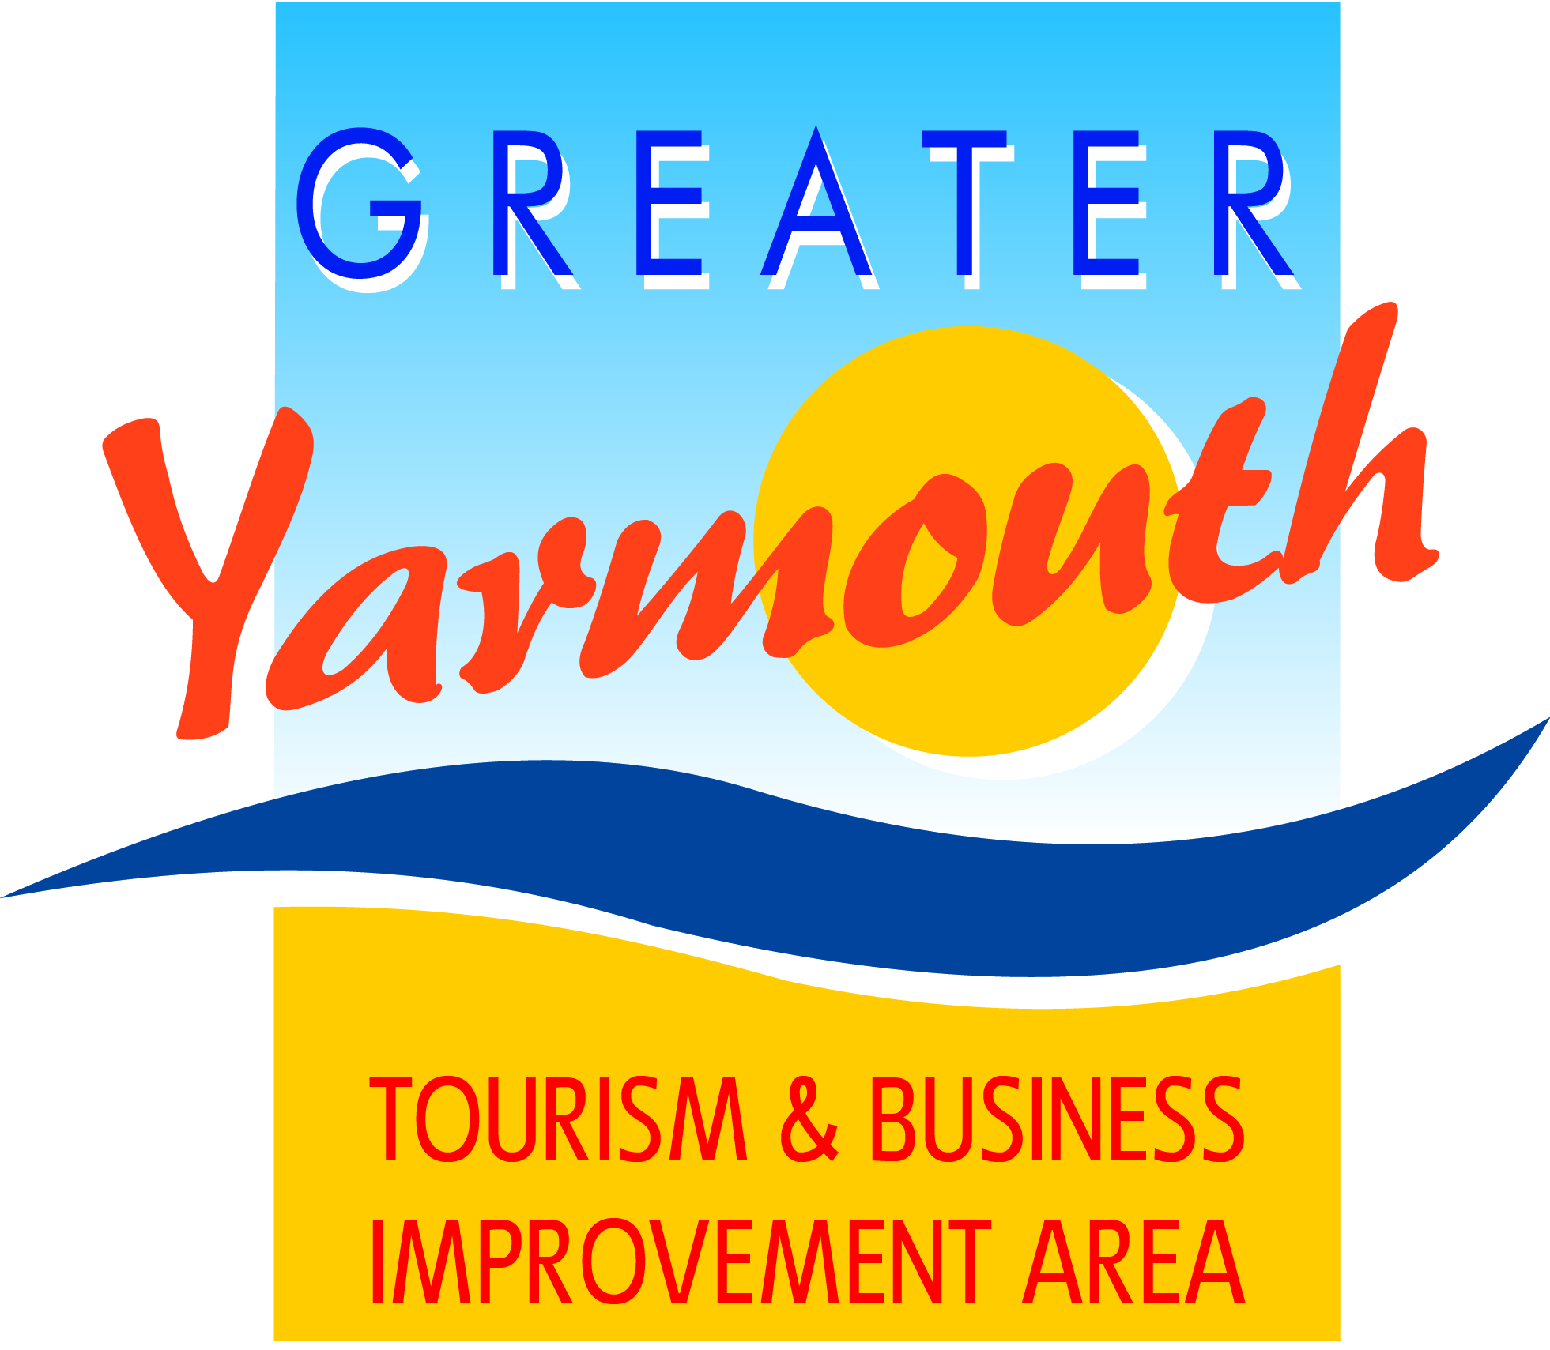

Minutes of the meeting of the
BOARD of the GREATER YARMOUTH TOURISM AND BUSINESS IMPROVEMENT AREA LTD
held on THURSDAY 10th September 2015
at Maritime House

Present:
David Marsh | Asa Morrison | Toni Reeve
Lyndon Bevan | James Gray | John Potter
Cllr Barry Coleman | Oliver Hurren | Amy Greenwood
Malcolm Bird | Jane Reynolds | Alan Carr
Ken Sims | Cllr Bert Collins (Hon President) | Karen Youngs
Terri Harris | Cllr Andy Grant | Kevin Huggins
Tony Smith | Cllr Katy Stenhouse | Peter Jay
Toni Reeve | Cllr Michael Jeal
Kirsty Burn | Cllr Demetrious Mavroudis (Observer)

1.0 |  | APOLOGIES FOR ABSENCE
 | 1.1 | Apologies were received from Andrew Bowyer, Jonathan Newman, Linda Dyble
2.0 |  | MINUTES OF THE PREVIOUS MEETINGS
 | 2.1 | The minutes of the BID Board meeting on 16th July 2015 were approved as a true and accurate record.
3.0 |  | MATTERS ARISING FROM THE MINUTES
 | 43.2 | Ref 20.2.4 Esplanade Banners/Beach Cannons/North Drive Decorative Lighting
 |  | Cllr Jeal reported that the beach cannons were in good working order the continued cost for maintenance of the bulbs was the issue. GYBS have asked for a clear steer from GYTABIA about the future of the cannons. Cozens to be chased for projected budget for enhanced technology to replace the outdated and expensive bulbs.
 | 43.3 | Cllr Bird reported that the North Drive LED’s were being repaired in 2 weeks.
 | 43.4 | Spirit of Enterprise Awards
 |  | Still 2 seats available for the Awards night on the 20th November
 | 43.5 | British BIDs
 |  | More investigation was needed before committing to accreditation with British BIDs.
 | 43.6 | Study Visit
 |  | Need to check that the proposed date in October does not clash with the In Bloom judging.
 |  | Need to look at a wider range of businesses to visit within the trip including High Streets and Services & Suppliers to include interests of all BID levy payers.
 |  | We have been invited to speak to Weston super-mare about our BID
 |  | Need to put out study visit details later this year to find expressions of interest.
4.0 |  | LEVY COLLECTION UPDATE
 | 4.1 | Projection of £480k income this year. To date we have received £439,714.00
 | 4.2 | £325k has been received from GYBC to date
 | 4.3 | VAT complications to be ironed out at a meeting on Monday to agree the SLA’s
5.0 | 5.1 | REPORT ON FIREWORKS RESEARCH
 |  | Some scepticism on value of research particularly without a baseline. Suggestion of doing another evening as a control point. A copy of the report would be issued out upon request.
6.0 |  | FINANCIAL AND COMPANY ISSUES
 | 6.1 | Budget
 |  | Projected budget papers were handed out. (Please see attached)
 | 6.2 | Board Elections
 |  | Board elections to be carried out early next year. The papers when issued will indicate all areas/trades to be represented on the board. The new chairman will be elected at the first new board meeting in March 2016
 | 6.3 | PIPs
 |  | Did not win contract for PIPs so will cease trading 31st October. Columns have to be removed by that date.
 |  | Old columns proposed to be used by placing on private land such as holiday parks and attractions with the intention of selling advertising. 1/3 to be used for advertising GYTABIA events, 1/3 to be used by the business whose land it is, 1/3 to be used as advertising to bring in an income.
 |  | Cllr Jeal congratulated David Marsh for doing an exceptional job under very difficult circumstances
7.0 |  | PROJECTS UPDATE
 |  | See attached
8.0 |  | KEY PROJECTS 2015-2016
 | 8.1 | Great Yarmouth & Hemsby Fireworks
 | 8.1.2 | Great Yarmouth Fireworks dates agreed at 27th July 2016 to 31st August 2016 & a date in October
 |  | Possibility of going out to tender as a combined tender between Gorleston, Hemsby & Great Yarmouth suggested.
 | 8.1.3 | Agreed that longer display time is not necessary but an enhancement would be the key.
 | 8.1.4 | Suggestion for music timed with fireworks would prove impossible without financing a sound system along the Esplanade – Great Yarmouth
 | 8.1.5 | Reported that compensation had been paid to a trader whose property had been damaged reportedly due to cinder debris from fireworks – Great Yarmouth
 | 8.2 | Maritime Festival 2016
 | 8.2.1 | 2016 dates will be the 10th and 11th September
 | 8.2.2 | Reported that the Saturday of this year had been the best Saturday of the life of the festival
 | 8.2.3 | The Board thanked Alan for all his hard work on the Festival
 | 8.2.4 | The Board agreed to write to Aileen and thank her for her hard work on the Festival
 | 8.3 | Gorleston High Street Christmas Light Switch on
 |  | November 22nd from 12 noon with fireworks at 6pm and ice skating rink in Priory Gardens to encourage whole use of High Street.
9.0 |  | PROJECTS FOR DISCUSSION
 | 9.1 | Car Park Discount Scheme
 |  | Another meeting needed to further project.
 | 9.2 | Comedy Week
 |  | A project to encourage adults without children. Would run from Saturday for 10 days through to Sunday. Possibility of June/July or September/October. Venues to finance the cost of the event and the BID company to provide the marketing and co-ordination package. Board agreed to further scoping out.
 | 9.3 | Eating Out Week
 |  | Another project to encourage adults without children. Would run from Saturday for 10 days through to Sunday. Possibility of June/July or September/October. Venues to finance the cost of the event and the BID company to provide the marketing and co-ordination package. Board agreed to further scoping out.
 | 9.4 | Airshow 2017
 |  | Projected date for the airshow is Thursday 29th June through to Sunday 2nd July. Progress has been made and the early signs are that this would be a very viable project. Board agreed for Asa to continue working on project and bring some projected budget figures to the next Board meeting.
10.0 |  | CONTRACTUAL PROJECTS
 | 10.1 | Decorative Lighting
 |  | Decorative lighting the rolling repairs need to be kept updated. Festive lighting to be chased.
11.0 |  | APPLICATION PROCESS 2015-16
 | 11.1 | The latest updated funding application forms to be sent out with newsletter inviting businesses to come forward with ideas for projects by 31st October 2015
12.00 |  | COMMUNCIATIONS
13.00 |  | AOB
 |  | A webcam in Hemsby suggestion was put forward although a suitable location would have to be found.
14.00 |  | DATE OF NEXT MEETING
 |  | 12th November 2015

