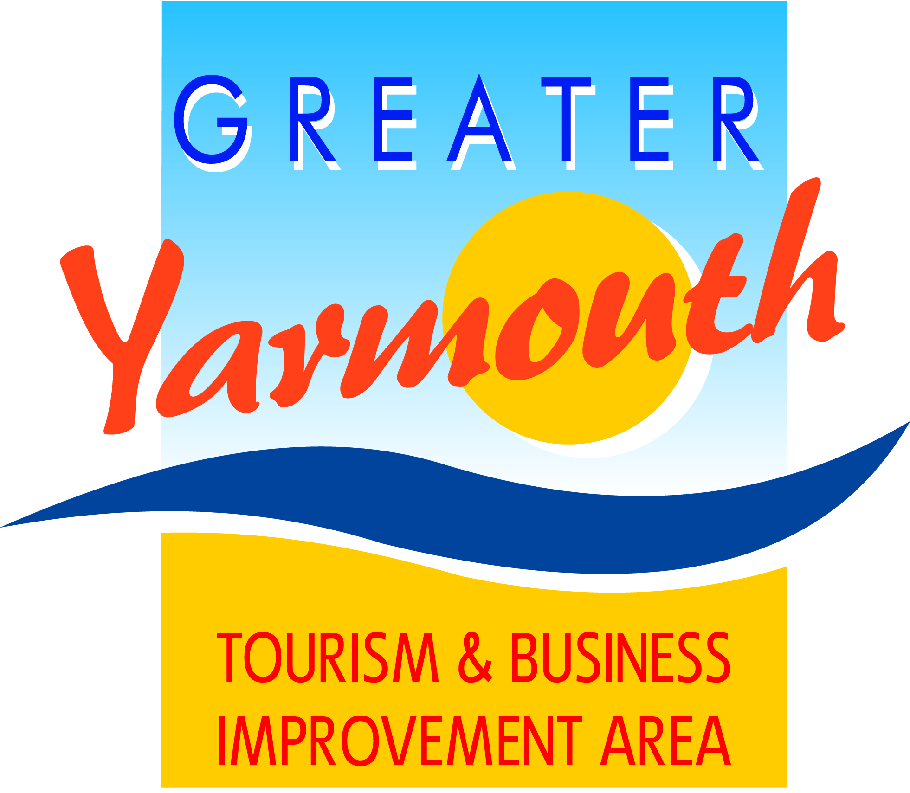

Minutes of the meeting of the
BOARD of the GREATER YARMOUTH TOURISM AND BUSINESS IMPROVEMENT AREA LTD
held on Friday 20th November 2015
at Maritime House
Present:
David Marsh | Asa Morrison | Cllr Michael Jeal
Lyndon Bevan | James Gray | Peter Jay
Cllr Barry Coleman | Oliver Hurren | Tony Smith
Andrew Bowyer | Jane Reynolds | Alan Carr
Ken Sims | Cllr Bert Collins (Hon President) | Karen Youngs
Terri Harris | Cllr Andy Grant | Kevin Huggins
Kirsty Burn

1. |  | APOLOGIES FOR ABSENCE
 | 1.1 | Apologies were received from albert Jones, Jonathan Newman, Cllr Katy Stenhouse, Linda Dyble, Malcolm Bird, Toni Reeve
2. |  | HOW WAS THE 2015 SEASON?
 |  | Sealife Centre - busiest year recorded
 |  | Thrigby - up on 2014
 |  | Lost World Golf - same as 2014
 |  | MB’s Hemsby - Good until August
 |  | Your Move - markets picking up occupancy good
 |  | Hippodrome – 20% up
 |  | Sara’s Tearooms – marginally up on 2014
 |  | Cherrytree – 20% up
 |  | Merivon Guest House – up on 2014
 |  | Fusion – trading good holding our own
3. |  | MINUTES OF THE PREVIOUS MEETINGS
 | 3.1 | The minutes of the BID Board meeting on 10th September 2015 were approved as a true and accurate record.
4. |  | MATTERS ARISING FROM THE MINUTES
 | 4.1 | Ref 20.2.4 Esplanade Banners/Beach Cannons/North Drive Decorative Lighting
 |  | Cllr Coleman reported that the IT engineer at St. Georges had reported it was possible to reprogramme the Nemos and Beach cannons for different lighting colours. Also possible to change the bulbs to LED’s
 | 4.2 | Spirit of Enterprise Awards
 |  | GYTABIA Table now full
 | 4.3 | Study Visit
 |  | Bring to the next board meeting for a decision
5. |  | LEVY COLLECTION UPDATE
 | 5.1 | Court hearing 1 month ago. Total of 5 people attended with 4 people settling their levy on the day. 1 went to court but was ordered to pay the levy.
 | 5.2 | Invoices went out September for a total of £490k of which £300k has been collected. 557 reminders have been sent out. Far less backlash this year from levy payers against the BID
 | 5.3 | The BID also has voluntary members including for the first time Pleasurewood Hills.
 | 5.4 | A press release has been sent out about a car being purchased by a member of the public whilst on holiday in the area and also about the number of cars/vans leased by holiday parks.
6 |  | FINANCIAL AND COMPANY ISSUES
 | 6.1 | Budget
 |  | Projected budget papers were handed out. (Please see attached)
 | 6.2 | Board Elections
 |  | Members discussed the proposed election protocols and agreed that it was important for the Board to maintain a spread across business types/geographical area/rateable value. The protocol were subsequently agreed
 | 6.3 | The new board would be elected by the 3rd March and announced at the AGM on the 10th March 2016
 | 6.4 | PIPs
 |  | The PIPs were removed by the 31.10.15. Offers of help were received from Peter Jay, Andrew Bowyer, Michael Jeal, Asa Morrison and Oliver Hurren. They were subsequently removed by East Coast Property Maintenance who did an excellent job within time. The PIPs are currently in storage.
 | 6.5 | The Board supported the proposal to be use the columns on private land such as holiday parks and attractions with the intention of selling advertising. 1/3 to be used for advertising GYTABIA events, 1/3 to be used by the business whose land it is, 1/3 to be used as advertising to bring in an income. A firm proposal would be brought to a future board meeting.
7. |  | PROJECTS APPRAISALS
 | 7.1 | It was agreed that only board members present could score the appraisal sheets.
 | 7.2 | Agreed to discuss proxy members at the next board meeting
 | 7.3 | A vote was taken whether the strategic scoring should be known by the board prior to voting – It was voted against.
 | 7.4 | All project applications were then discussed by Board members who ranked all projects from 5 points (top score) to 1 point lowest score. The combined score of all board members present resulted in a ‘Ranking Score’ for each project. (see Appendix 1)
8. |  | AOB
 |  | Asa Morrison presented an options paper on the annual awards. The proposal came out of a recently held working group. Members agreed to continue with the Annual Tourism & Business Awards based on a levy payer nominations and a subsequent vote by paid and signed up members.
10. |  | DATE OF NEXT MEETING
 |  | 28th January 2016

Appendix 1
No | Category | Project | Proposed  Adjustments | 2015-2016 | Priority Score | Strat Score | Total
 |  | LARGE EVENTS PROJECTS
1 | Events | Airshow 2017 |  | £22,200 | 60 | 72 | 4320
4 | Events | Eating Out Week |  | £18,400 | 54 | 49 | 2646
 |  |  |  | £40,600
 |  | SMALL EVENT PROJECTS (Under £10,000)
15 | Events | UK Beach Volleyball |  | £4,500 | 55 | 49 | 2695
14 | Events | National Schools Sailing Regatta Gorleston 2016 |  | £7,920 | 54 | 49 | 2646
9 | Events | GY Wheels Festival |  | £5,950 | 46 | 48 | 2208
5 | Events | Gorleston Cliff Top Fireworks |  | £2,000 | 50 | 40 | 2000
6 | Events | GY Arts Festival |  | £8,375 | 47 | 42 | 1974
2 | Events | Brush With the Broads |  | £4,250 | 38 | 48 | 1824
7 | Events | GY Film Festival |  | £8,000 | 30 | 40 | 1200
13 | Events | Martham Scarecrow |  | £500 | 42 | 26 | 1092
11 | Events | Hopton (10th) Summer Fete & Carnival |  | £2,032 | 31 | 35 | 1085
3 | Events | Comedy Week (£18,000 withdrawn) |  |  | 0 | 51 | 0
 |  |  |  | £43,527
 |  | FMA PROJECTS (Under £10,000)
17 | FMA | Car Parking Discount Scheme |  | £20,000 | 53 | 52 | 2756
24 | FMA | Station Welcome Hosts |  | £4,500 | 43 | 55 | 2365
19 | FMA | Filby in Bloom |  | £3,000 | 49 | 46 | 2254
27 | FMA | Winterton Improvements maps etc |  | £2,860 | 43 | 42 | 1806
16 | FMA | Access Gateways | £40,000 | £12,000 | 38 | 33 | 1254
20 | FMA | Gorleston Ivy Lodge Project |  | £5,000 | 49 | 24 | 1176
21 | FMA | Hemsby Hanging Baskets |  | £3,290 | 41 | 26 | 1066
18 | FMA | CCTV | £15,000 | £5,000 | 33 | 25 | 825
23 | FMA | South Beach/North Denes planting | £4,750 |  | 44 | 17 | 748
25 | FMA | Vauxhall Bridge (Suggested contribution) | £5,000 |  | 45 | 15 | 675
26 | FMA | Winterton (playground) | £6,299 |  | 23 | 29 | 667
22 | FMA | Scratby Brown Signs |  | £3,000 | 24 | 22 | 528
 |  |  |  | £58,650
 |  | MARKETING PROJECTS
 | MKG | Marketing |  | £166,000
 | MKG | Hemsby Promotional Leaflet |  | £3,000
 |  |  |  | £169,000
 |  | PROJECTS ALREAY COMMITTED
 |  | Seafront Decorative Lighting |  | £13,000
 |  | Footfall Monitoring |  | £4,250
 |  | Norfolk Tourism |  | £8,000
 |  | Gorleston Switch-On |  | £9,300
 |  | GY Summer Fireworks |  | £25,755
 |  | Hemsby Fireworks |  | £12,200
 |  | Maritime Festival |  | £25,000
 |  |  |  | £97,505
 |  |  |  | £409,282

