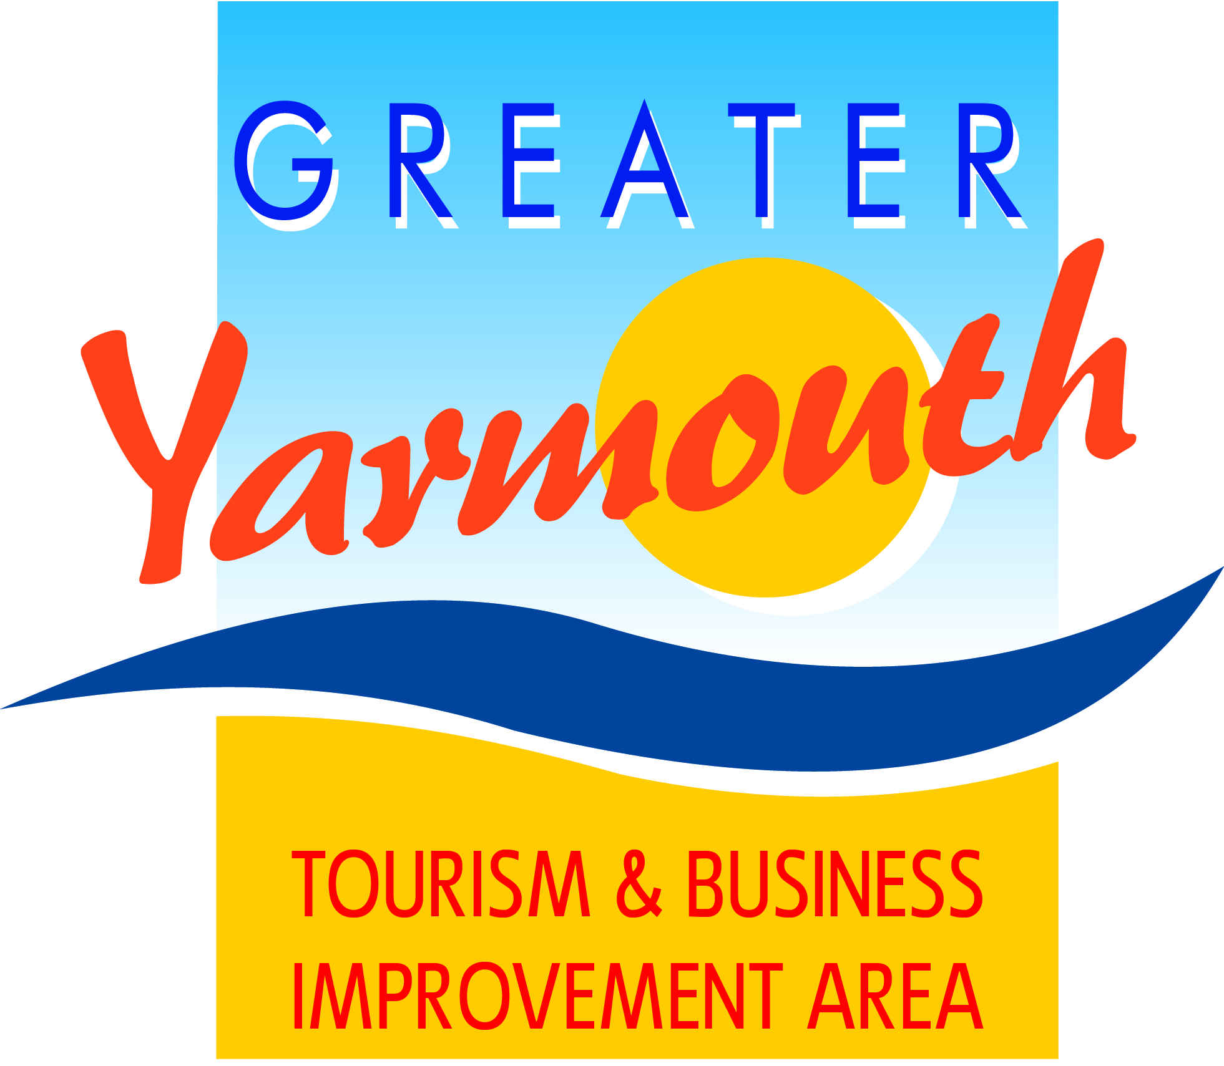

GYTABIA GORLESTON GROUP
Thursday 24th November 2016
AT 6.00PM

Gorleston Library

- Introductions

- enterpriseGY Training

- Review/Feedback on 2016 Events
  - UK Beach Volleyball
  - Support for Cliff Top Festival Fireworks
  - Xmas Switch-On
  - Ivy Lodge
  - Sailing Regatta

- Review of 2017 BID supported Gorleston projects

- Update of 2017 Air show

- Any Other Business

