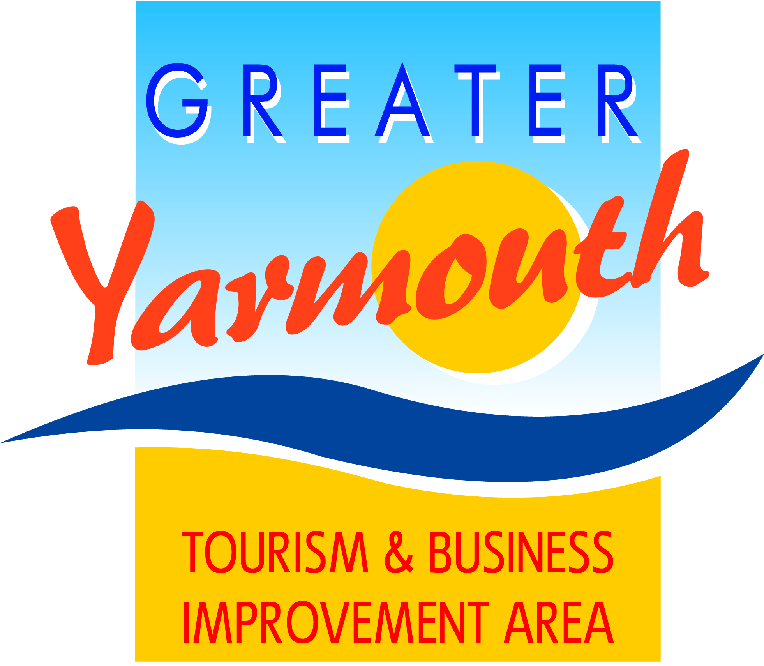

ANNUAL
TOURISM & BUSINESS AWARDS LUNCHEON
12 noon for 12.30pm
Wednesday 21st March – Assembly Rooms
Town Hall, Great Yarmouth

I/We would like to attend the Annual Tourism Awards Lunch
Please send me ……...tickets @ £20.00 each
(Please note: Tables can also be booked for up to 8, 9 or 10 people)
No. | NAME | Vegetarian or other dietary requirements
1
2
3
4
5
6
7
8
9
10

When ordering luncheon tickets please make cheques payable to:-
GREATER YARMOUTH TOURISM & BUSINESS IMPROVEMENTS AREA LTD
OR ‘GYTABIA’
Name
(for correspondence)
Business name
(if applicable)
Preferred correspondence Address
Email Address

Telephone number
Please return this form with your cheque to : Maritime House, 25 Marine Parade
Great Yarmouth NR30 2EN
This year’s event is sponsored by Booker Wholesale

