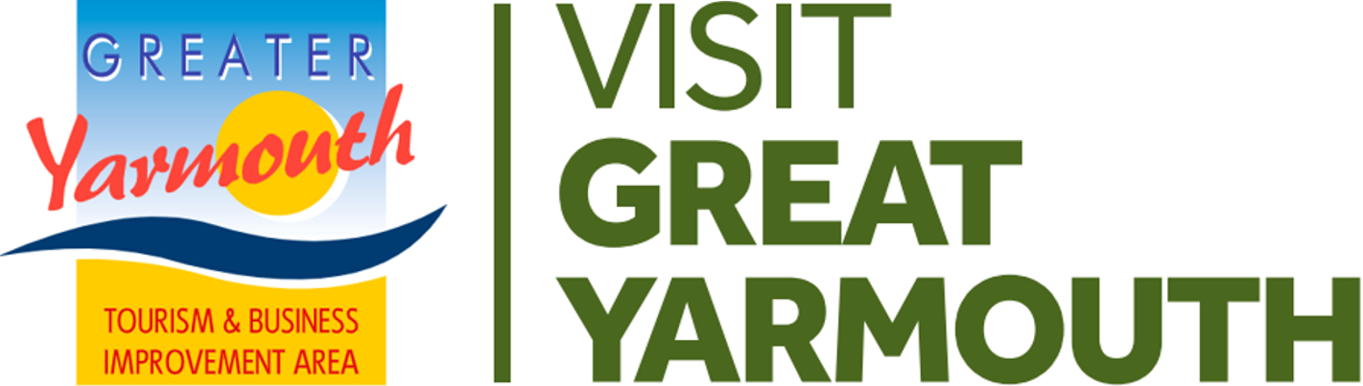 | FUNDING APPLICATION FORM  Facilities, Maintenance, Access

SECTION 1 | CONTACT DETAILS
Name of Group/Organisation
Legal status: ie Are you Ltd company or similar
Email
Telephone
Correspondence Address
Date of Application

SECTION 2 | THE PROJECT
Name of Project
Date/Dates Project is Planned to take place
Please state the amount of VGY/GYTABIA funding you are applying for:- | £
Please describe the project
Is this a one-off request or an annual request for funding or an annual project?
Who is the target user ie who will it benefit?
Objectives | Please order/rank the following objectives from 1 to 4 to demonstrate which best fits your project
 | OBJECTIVES | 1-4
 | To increase the number of people visiting and staying in Greater Yarmouth
 | To improve the visitor experience and increase repeat visits
 | To encourage people to stay longer and visit more attractions
 | To provide incentives and opportunities to spend more in local businesses
How will you measure the success of your project?

SECTION 3 | ACCOUNTS/INCOME & EXPENDITURE
Please attach a statement based around the following headings. Use a separate sheet if preferred
EXPENDITURE | £ | INCOME | £
Core | £ | Sponsorship | £
Add lines as appropriate | £ | Add lines as appropriate | £
Add lines as appropriate | £ | Add lines as appropriate | £
Add lines as appropriate | £ | Any other income | £
Other costs | £ | GYTABIA Grant (Applying for) | £
TOTAL EXPENDITURE | £ | TOTAL INCOME | £
Please include a copy of accounts for a previous year
To help you determine the suitability of your project please complete the following questionnaire:-
SECTION 4 | PROJECT ASSESSMENT
Has the project been promoted and/or supported by a sector group?
How does the project increase the number of people visiting Greater Yarmouth?
How does the project increase the number of people staying in Greater Yarmouth?
How does the project improve the visitor experience?

How does the project increase repeat visits?

How does the project encourage people to stay longer?

How does the project encourage people to visit more attractions?

How does the project provide incentives to spend more in local businesses?
How does the project provide opportunities to spend more in local businesses?
How does the project generate any income sources/match funding?
How does the project improve the physical environment?

How does the project improve the awareness of the destination?
How does the project benefit most sectors of the BID?

How does the project benefit the whole BID area (the Borough/Destination)?

SECTION 5 | SAFETY CHECK
Are there any measures in place to mitigate against the coronavirus?
Please explain the measures
1
2
3
4

Please return your completed application form
NO LATER THAN FRIDAY 8th OCTOBER 2021
via email to: info@gyta.com

Events Project Application Form Closing 8 OCTOBER 2021

