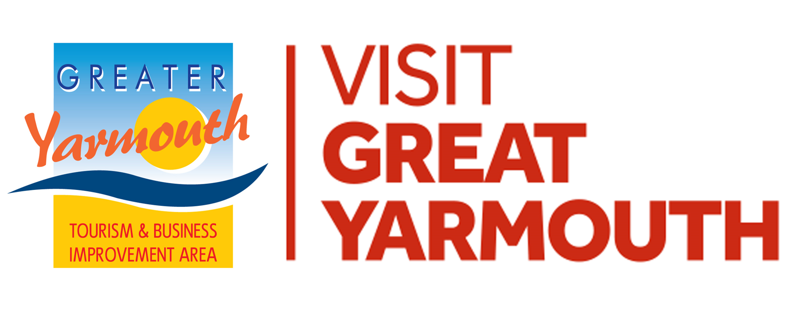 | FUNDING APPLICATION FORM  EVENTS

SECTION 1 | CONTACT DETAILS
Name of Group/Organisation
Legal status: ie Are you Ltd company or similar
Email
Telephone
Correspondence Address
Date of Application

SECTION 2 | THE PROJECT/EVENT
Name of Event
Date/Dates Event is Planned to take place
Please state the amount of funding you are applying for: from VGY/GYTABIA | £
Please describe your Event
Is this a new event or a annual event?
Who is the target audience ie who will it benefit?
Objectives | Please order/rank the following objectives from 1 to 4 to demonstrate which best fits your project
 | OBJECTIVES | 1-4
 | To increase the number of people visiting and staying in Greater Yarmouth
 | To improve the visitor experience and increase repeat visits
 | To encourage people to stay longer and visit more attractions
 | To provide incentives and opportunities to spend more in local businesses
How will you measure the success of your project?

SECTION 3 | ACCOUNTS/INCOME & EXPENDITURE
Please attach a statement based around the following headings. Use a separate sheet if preferred
EXPENDITURE | £ | INCOME | £
Core attractions | £ | Sponsorship | £
Site Management | £ | Income from trade stalls including food | £
Publicity | £ | Income from charged admissions | £
Paid Staff | £ | Any other income | £
Other costs | £ | GYTABIA Grant (Applying for) | £
TOTAL EXPENDITURE | £ | TOTAL INCOME | £
Please include a copy of accounts for a previous year
To help you determine the suitability of your project please complete the following questionnaire:-
SECTION 4 | PROJECT ASSESSMENT
Has the project been promoted and/or supported by a sector group?
How does the project increase the number of people visiting Greater Yarmouth?
How does the project increase the number of people staying in Greater Yarmouth?
How does the project improve the visitor experience?
How does the project increase repeat visits?
How does the project encourage people to stay longer?
How does the project encourage people to visit more attractions?
How does the project provide incentives to spend more in local businesses?
How does the project provide opportunities to spend more in local businesses?
How does the project generate any income sources/match funding?
How does the project improve the physical environment?
How does the project improve the awareness of the destination?
How does the project benefit most sectors of the BID?
How does the project benefit the whole BID area (the Borough)?

SECTION 5 | SAFETY CHECK

No | CHECK | Please write YES or NO
1 | Will the Event have an Event Management Plan (EMP) which includes measures to mitigate against the coronavirus?
2 | Can you confirm that you will submit your EMP to the local Event Safety Advisory Group (ESAG)?
3 | Do you give us permission to share your contact details with ESAG?
4 | Have you, or do you plan to take out insurance cover ie Public Liability and if necessary ‘Employers Liability’?
5 | Will your event still go ahead without our funding?

Please note we will not fund your event, if you do not have ESAG permission

Please return your completed application form
NO LATER THAN TUESDAY 16th NOVEMBER 2021
via email to: info@gyta.com

Events Project Application Form Closing 16th November 2021

