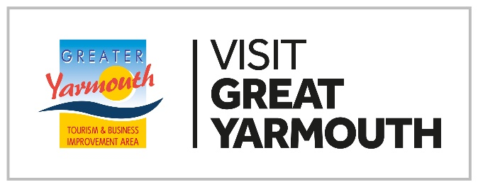

Voluntary Membership of Visit Great Yarmouth/ GYTABIA Ltd 2024/2025

If you are not already a levy payer and your business is ‘tourism’ related and located within the Borough of Great Yarmouth, you have the opportunity to apply to become a voluntary member of Visit Great Yarmouth.

Under the guidance of our business led sector groups, we run several activities and programmes, that really could directly support your business.

We also undertake a number of wider activities
- We undertake a significant amount of PR and Marketing for the Great Yarmouth area working with major national titles and media brands, regularly receiving over two million pounds worth of media coverage. We are currently planning for our 2025 marketing drive and want to continue to build on this.
- We deliver the Great Yarmouth Wheels Festival, Hemsby Summer Fireworks (Big Tuesdays), and Great Yarmouth summer fireworks (Big Wednesdays), which all have received significant enhancements to ensure it continues to exceed the expectations of our visitors and drive significant footfall to the area.
- We deliver projects which enhance the facilities, maintenance, and access such as enhanced decorative lighting, security by funding CCTV monitoring and provision of cameras.
- We continue to strive to build an all-year-round tourism industry, develop our overall offer, and build our core summer product.
- We provide business intelligence to support you as well as primary and secondary research to understand our visitors enabling us to reach or exceed our visitor’s expectations.
- We have developed strong local, regional, and national links, so we are able to take our tourism issues and challenges facing Great Yarmouth to the right decision makers.
- We also support skills development to improve the skillset of the local workforce.
- You can find out of all of the above in detail on our corporate website https://gyta.com/

VOLUNTARY MEMBERSHIP

Voluntary Membership is open to tourism related business, as categorised in the business plan (Insert link), who are located within the borough and have a rateable value under £12,000 (or under £2,500 for visitor accommodation category businesses).

Voluntary membership is £250 + VAT per annum.

Benefits Include:
- Free enhanced listing on our visitor website www.visitgreatyarmouth.co.uk (which receives 650,000 unique visits per annum)- includes opportunity for up to 20 images and direct link to your website.
- Listings on carousel, on landing page and other areas of the website
- Opportunity to be promoted in PR package including promotions through Instagram/Facebook/customer newsletters to over 20,000 visitors
- Discounted advertising within our printed ‘What’s On’ Guide (100,000 printed)-
- Digital Guide downloadable on our website (only available for accommodation & attraction providers)- free accommodation and attractions adverts for voluntary members
- Opportunity to be included in PR campaign
- Opportunity to be involved in free training and events
- Opportunity to be included in press trips, competitions, newsletters
- Opportunity to host Journalists, Bloggers, and Influencers
- Invitations to our members visits and open forums
- Opportunity to be included in campaigns for onsite photography and access to our images
- Regular news updates and event updates
- Access to become involved in our working groups

Your membership of Visit Great Yarmouth/GYTABIA would provide the opportunity become involved in our working groups giving you a voice in the future our visitor economy.

As a voluntary member you have the opportunity you to put yourself forward as a board member. To qualify you must be a paid up and signed up member of the company for a minimum period of 1 year.

Please note, there is a limit applied to the number of voluntary members represented on the board.

If you have any queries or require any further information, please do not hesitate to contact us. We would love to hear from you and have the opportunity to work together

If you are interested in becoming a member, please contact us via email at karen@gyta.com

A Morrison 170125

