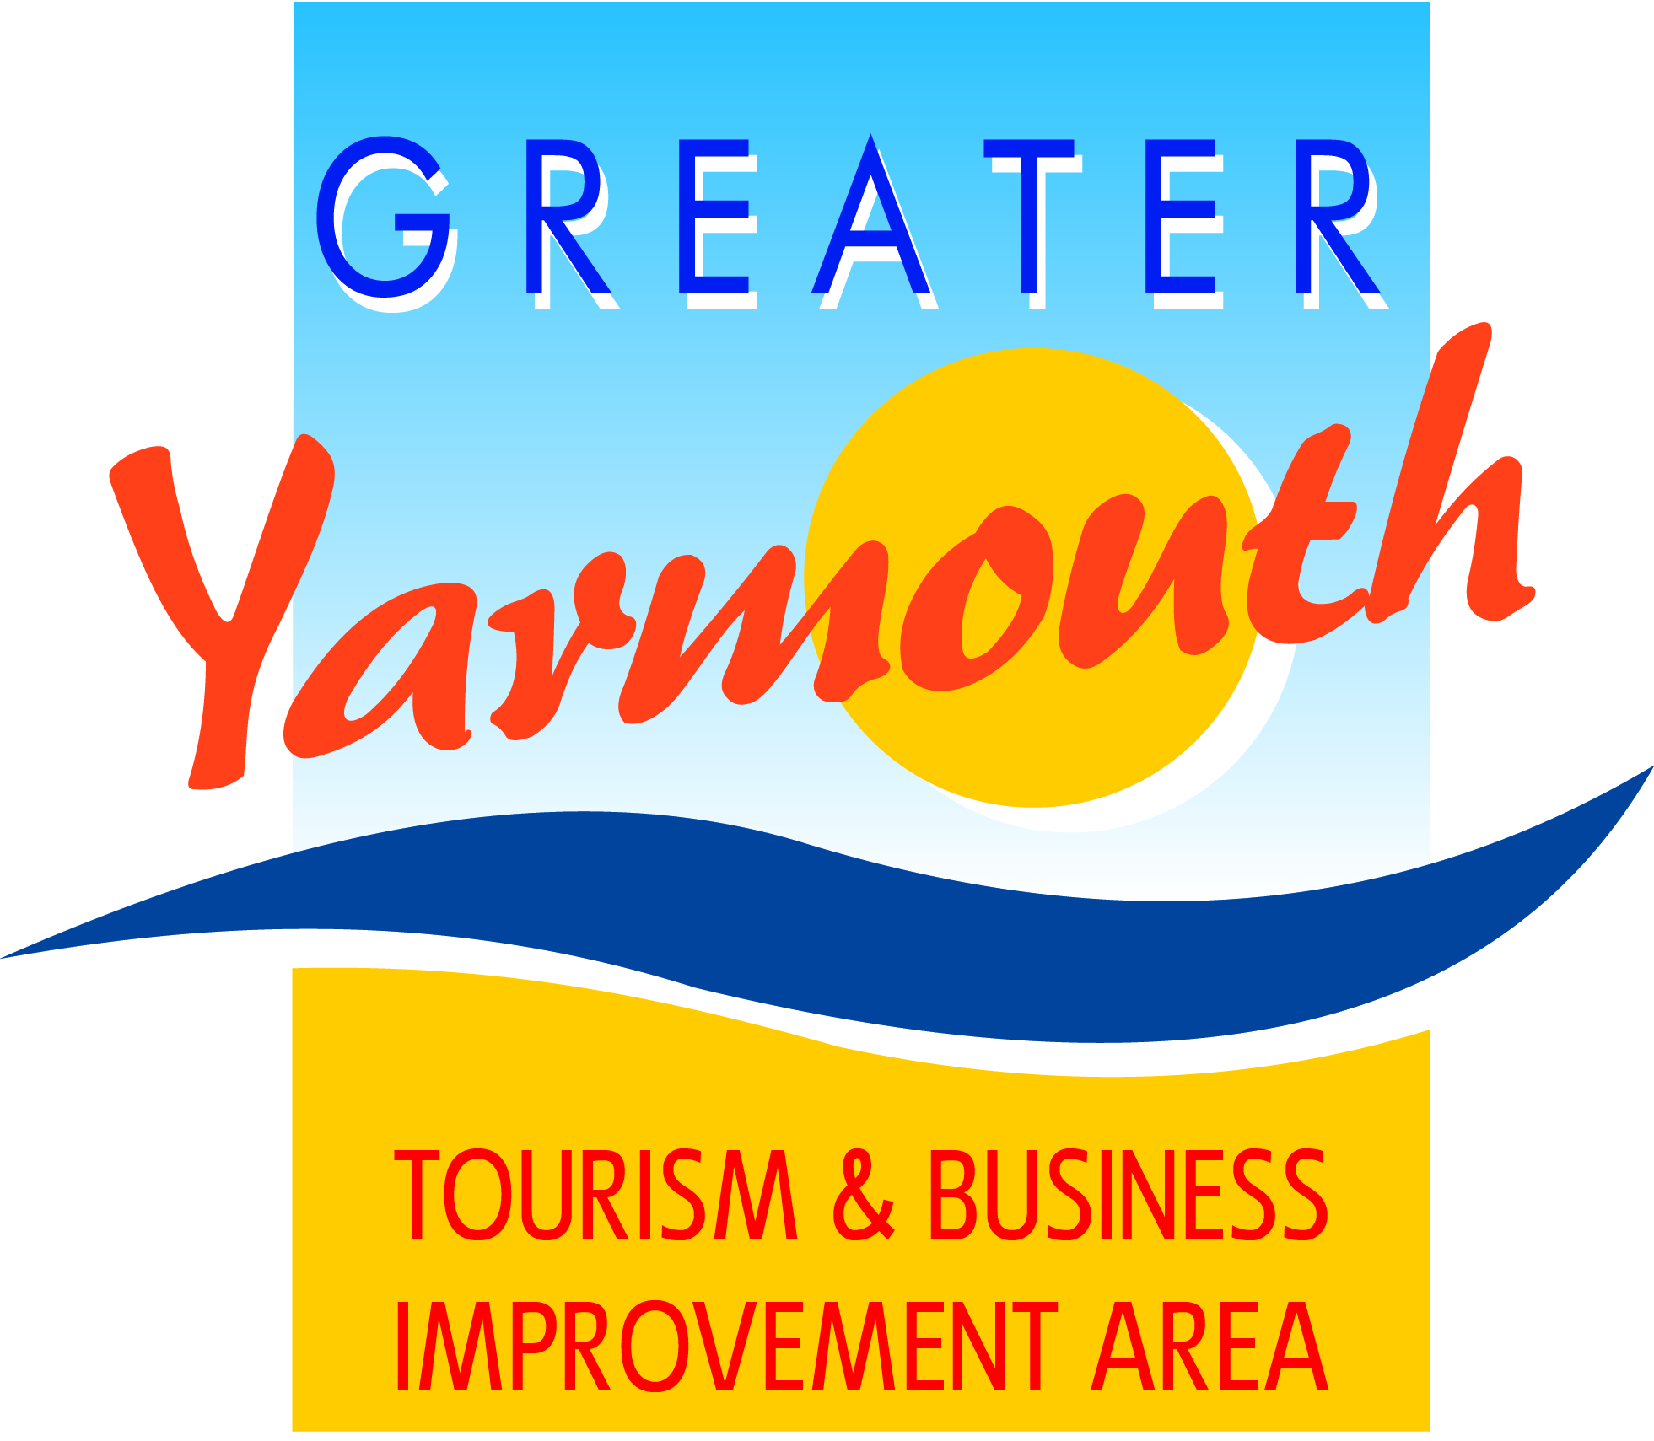

Minutes of the meeting of the
BOARD of the GREATER YARMOUTH TOURISM AND BUSINESS IMPROVEMENT AREA LTD
held on Thursday 28th January 2016
at Maritime House
Present:
David Marsh | Asa Morrison | Cllr Michael Jeal
Lyndon Bevan | James Gray | Peter Jay
Peter Jay | Oliver Hurren | Tony Smith
Darren Cross | Jane Reynolds | Alan Carr
Amy Greenwood | Cllr Bert Collins | Karen Youngs
Terri Harris | Cllr Andy Grant | Kevin Huggins
Kirsty Burn | John Potter | Katy Stenhouse
Malcolm Bird | Albert Jones | Kellie Colby
Toni Reeve

Prior to Meeting - Screening of the new TV Commercial and webisodes for those that missed the premier event held in December
Congratulations were given to Kirsty for the excellent quality of the commercial and webisodes
1. |  | APOLOGIES FOR ABSENCE
 | 1.1 | Apologies were received from Jonathan Newman.
2. |  | MINUTES OF THE PREVIOUS MEETINGS
 | 2.1 | The minutes of the BID Board meeting on 20th November 2015 were approved as a true and accurate record.
3. |  | MATTERS ARISING FROM THE MINUTES
 | 3.1 | Ref 20.2.4 Esplanade Banners/Beach Cannons/North Drive Decorative Lighting
 |  | No update on banners or cannons. Marine Parade illuminations which were currently not working to be chased. North Drive illuminations were on for 2 weeks over Christmas but now some are not working this is being fixed today.
4. |  | FINANCIAL AND COMPANY ISSUES
 | 4.1 | Levy Collection Update
 |  | Members were informed that although there was no recent update that the collection rate was healthy. This year has seen an additional 80 more properties in the borough BID area. Investigations will be made for the latest collection update for the next Board meeting.
 | 4.2 | Budget
 |  | The budget sheet is attached – see appendix 1
 | 4.3 | Constitution
 |  | No constitutional matters
 | 4.4 | Director Nominations
 |  | All nominees for director of the board have to be a member of the company for 12 months. The Chairman would be elected by the Board. Directors term of office will be either for a one or two year term - to be determined at a later date which director does which term. New Board members to be ratified at the AGM on the 10th March 2016
5. |  | BUDGET ALLOCATIONS FOR PROJECTS (Appendix 1)
 | 5.1 | In the budget papers the priority score is the Board score; and the strategic score is the BID Executive score.
 | 5.2 | Access Gateways – this project requires a Project Manager to move it forward – this year the budget has been reduced until the Project Manager is in place.
 | 5.3 | Vauxhall Bridge – this project did not score highly so the £5k budget requested was not given, however an objection was raised which was seconded and a vote taken to award the funding application. The motion was carried and the project was awarded the £5k funding applied which was taken from the Access Gateway project budget.
 | 5.4 | CCTV – Objections were raised about funding this project however the £5k funding was not removed.
 | 5.5 | Scratby Sign – Funding for the Scratby sign was not awarded originally however the decision was reversed and the project was awarded funding based. It was noted of the importance of showing that decisions can be reversed if it was felt that a wrong decision had been made initially.
 | 5.6 | Winterton – grant funding has been agreed for playground equipment
 | 5.7 | Planters South Denes – An application has been made to GYBC for funding
 | 5.8 | Any disputes/appeals by businesses about inclusion in the BID categories should be referred to Karen Youngs
6. |  | AGM & ANNUAL TOURISM & BUSINESS AWARDS 10th MARCH 2016
 | 6.1 | There were 61 nominations for awards with nominations in all categories. These have now been sent to members of the company for the final vote.
7. |  | AIRSHOW UPDATE
 | 7.1 | Core area of Airshow for viewing purposes will be from the Pleasure Beach to the Hollywood Cinema although Gorleston and the north of Great Yarmouth will still have a reasonable view.
 | 7.2 | It will be proposed within the Event Plan to apply for road closures between the piers; park and ride services would be implemented in the North, South & West of the borough.
 | 7.3 | It will be proposed that Marine Centre & Jetty car park to be allocated as trading areas and/or sponsors parking.
 | 7.4 | It was hoped that a pre-booking on-line system for car parking would operate across the Borough.
 | 7.5 | Need to work with train companies and manage offshore boats
 | 7.6 | Port Company and energy companies will need 24 hour access through the show
 | 7.7 | Timings of displays will be approx 7-9 Thursday & Friday evening and 1-5 Saturday & Sunday afternoon. The spread of visitors across the 4 days is estimated at Thurs 50k; Friday 50k; Saturday 100k and Sunday £100k. It will be important to stagger their leaving by putting on additional events after the main displays.
 | 7.8 | Anticipated that the 1st draft of traffic management plan will be discussed by the Event Safety Advisory Group and completed by June/July.
 | 7.9 | GYTABIA is now a member of British Air Display Association.
8. |  | MILITARY TATTOO
 | 8.1 | Military Tattoo has now been cancelled due to competition with the Airshow For sponsorship
9. |  | ANNUAL STUDY VISIT
 | 9.1 | The date of the study visit will be the 1st or 2nd week of October and will be a 2-fold visit to Weston-super-mare to include both direct tourism and indirect tourism related agendas.
10. |  | AOB
 | 10.1 | Skegness BID team to visit Great Yarmouth on Monday as they recognise that to ensure that they remain competitive with other resorts they need a BID
11. |  | DATE OF NEXT MEETING
 | 11.1 | Thursday 3rd March 10.30am Maritime House

Appendix 1
No | Category | Project | Proposed  Adjustments | 2015-2016 | Priority Score | Strat Score | Total
 |  | LARGE EVENTS PROJECTS
1 | Events | Airshow 2017 |  | £22,200 | 60 | 72 | 4320
4 | Events | Eating Out Week |  | £18,400 | 54 | 49 | 2646
 |  |  |  | £40,600
 |  | SMALL EVENT PROJECTS (Under £10,000)
15 | Events | UK Beach Volleyball |  | £4,500 | 55 | 49 | 2695
14 | Events | National Schools Sailing Regatta Gorleston 2016 |  | £7,920 | 54 | 49 | 2646
9 | Events | GY Wheels Festival |  | £5,950 | 46 | 48 | 2208
5 | Events | Gorleston Cliff Top Fireworks |  | £2,000 | 50 | 40 | 2000
6 | Events | GY Arts Festival |  | £8,375 | 47 | 42 | 1974
2 | Events | Brush With the Broads |  | £4,250 | 38 | 48 | 1824
7 | Events | GY Film Festival |  | £8,000 | 30 | 40 | 1200
13 | Events | Martham Scarecrow |  | £500 | 42 | 26 | 1092
11 | Events | Hopton (10th) Summer Fete & Carnival |  | £2,032 | 31 | 35 | 1085
3 | Events | Comedy Week (£18,000 withdrawn) |  |  | 0 | 51 | 0
 |  |  |  | £43,527
 |  | FMA PROJECTS (Under £10,000)
17 | FMA | Car Parking Discount Scheme |  | £20,000 | 53 | 52 | 2756
24 | FMA | Station Welcome Hosts |  | £4,500 | 43 | 55 | 2365
19 | FMA | Filby in Bloom |  | £3,000 | 49 | 46 | 2254
27 | FMA | Winterton Improvements maps etc |  | £2,860 | 43 | 42 | 1806
16 | FMA | Access Gateways | £40,000 | £12,000 | 38 | 33 | 1254
20 | FMA | Gorleston Ivy Lodge Project |  | £5,000 | 49 | 24 | 1176
21 | FMA | Hemsby Hanging Baskets |  | £3,290 | 41 | 26 | 1066
18 | FMA | CCTV | £15,000 | £5,000 | 33 | 25 | 825
23 | FMA | South Beach/North Denes planting | £4,750 |  | 44 | 17 | 748
25 | FMA | Vauxhall Bridge (Suggested contribution) | £5,000 |  | 45 | 15 | 675
26 | FMA | Winterton (playground) | £6,299 |  | 23 | 29 | 667
22 | FMA | Scratby Brown Signs |  | £3,000 | 24 | 22 | 528
 |  |  |  | £58,650
 |  | MARKETING PROJECTS
 | MKG | Marketing |  | £166,000
 | MKG | Hemsby Promotional Leaflet |  | £3,000
 |  |  |  | £169,000
 |  | PROJECTS ALREADY COMMITTED
 |  | Seafront Decorative Lighting |  | £13,000
 |  | Footfall Monitoring |  | £4,250
 |  | Norfolk Tourism |  | £8,000
 |  | Gorleston Switch-On |  | £9,300
 |  | GY Summer Fireworks |  | £25,755
 |  | Hemsby Fireworks |  | £12,200
 |  | Maritime Festival |  | £25,000
 |  |  |  | £97,505
 |  |  |  | £409,282

