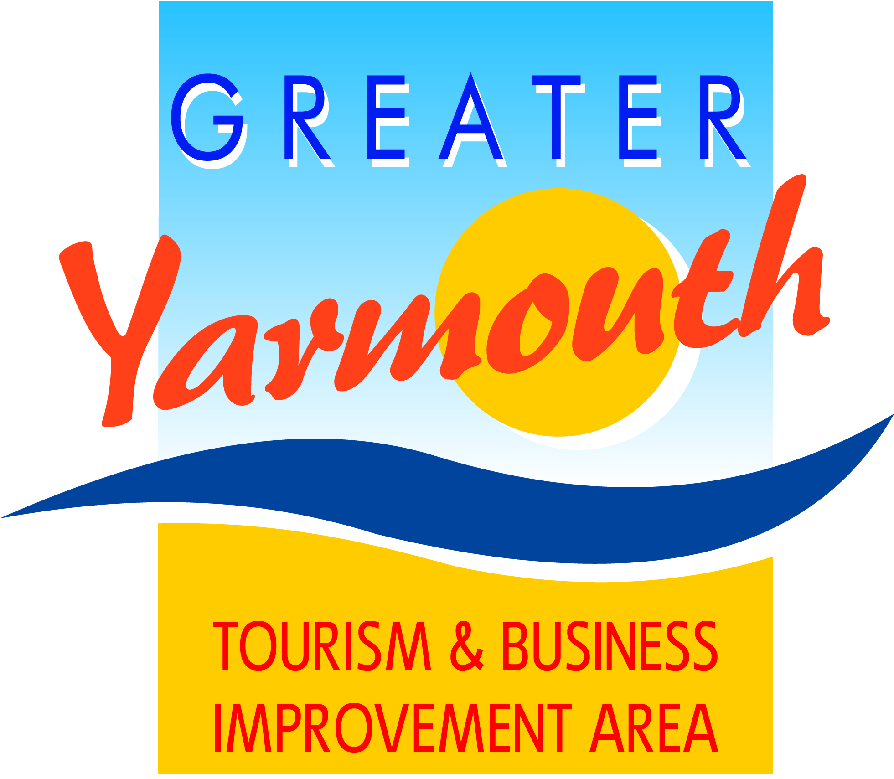

Minutes of the meeting of the
BOARD of the GREATER YARMOUTH TOURISM AND BUSINESS IMPROVEMENT AREA LTD
held on Thursday 3rd March 2016
at Maritime House
Present:
David Marsh | Asa Morrison | Katy Stenhouse
Gareth Brown (Chairman) | Ken Sims | Peter Jay
Toni Reeve | Albert Jones | Tony Smith
Lyndon Bevan | Jane Reynolds | Alan Carr
Amy Greenwood | Cllr Bert Collins | Karen Youngs
Terri Harris | Cllr Andy Grant | Kirsty Burn
Cllr Barry Coleman (Vice Chairman)

1. |  | APOLOGIES FOR ABSENCE
 | 1.1 | Apologies were received from Jonathan Newman, Malcolm Bird, John Potter, James Gray
2. |  | MINUTES OF THE PREVIOUS MEETINGS
 | 2.1 | It was recorded that Cllr Barry Coleman and Ken Sims had given their apologies for not attending the last meeting. The remainder of the minutes of the BID Board meeting on 3rd March were approved as a true and accurate record.
3. |  | MATTERS ARISING FROM THE MINUTES
 | 3.1 | There were no matters arising
4. |  | FINANCIAL AND COMPANY ISSUES
 | 4.1 | Levy Collection Update
 |  | Concern was raised about the way current information was given to GYTABIA on the updates of the BID levy collection.
 | 4.2 | Year End Accounts
The accounts will be proposed at the AGM – no objections from the Board. The accountants have suggested an audit for the company this was agreed that it would be good practice to prepare for the next BID ballot.
The budget sheet is attached – see Appendix A
Budget for the Norfolk & Norwich Festival performances of ‘The Tempest’ performance budget has been added. Reported that the Eating Out Week will not require as much funding as first thought. Vauxhall Bridge if no invoices received then the budget will be cut for this year.
 | 4.3 | Director Nominations
All nominees for director of the board have to be a member of the company for 12 months. The Chairman would be elected by the Board. Directors term of office will be either for a one or two year term - to be determined at a later date which director does which term. New Board members to be ratified at the AGM on the 10th March 2016
David Marsh nominated Gareth Brown as new Chairman seconded by Ken Sims and agreed by the board. It was agreed to do the handover at the AGM
 | 4.4 | Annual General Meeting & Tourism & Business Lunch
 |  | Tourism lunch preparations going well with a full house this will be preceded by the AGM at 11am in the Council Chamber.
 | 4.5 | Annual Study Visit – Weston Super Mare 11th/12th/13th October
 |  | Preparations for Weston are progressing well and should prove to be a most informational visit.
5. |  | BUDGET PROJECTS UPDATE
 | 5.1. | Air Show  -Ian Hacon named as head of corporate funding and it is hoped that the launch of the sponsors will be April/May. Asa Morrison reported that the favoured date for the airshow is the 15/18 June. Final decision to be made in September
 |  | -Meetings have been held with the Red Arrows at RAF Scampton and a display team from RAF Coningby. Safety regulations have been enhanced since the Shoreham disaster.
 |  | -The Great Yarmouth bid will be put forward in September for planes which gives a chance to garner sponsorship before we commit.
 |  | -The first Event Safety Advisory Group meeting was very encouraging
 | 5.2 | Discount Car Parking Scheme  -This project is progressing well and is hoped to be in operation by the 2nd week of the Easter holidays. It is anticipated that it will get off to a slow start but will gather momentum during the summer weeks.
 | 5.3 | Access Gateways  -This project is being scoped by the Paul Robinson Partnership and updates will be given to the board as and when received.
 | 5.4 | Webisodes  -Appendix attached
6. |  | PRESENTATION BY SEACHANGE ARTS
 | 6.1 | Cllr Coleman declared an interest in Seachange.  Seachange are keen to work in partnership with the GYTABIA. Funding is available from the Arts Council however Seachange need match funding in order to apply. Looking at applying for the match funding from the GYTABIA. A discussion was held followed by a vote where all were in favour.
7. |  | OUTSTANDING BID APPLICATIONS
 | 7.1 | None
8. |  | ANY OTHER BUSINESS
 |  | Peter Jay asked for a vote of thanks for the outgoing chairman Mr David Marsh and the board gave a round of applause.
9. |  | DATE OF NEXT MEETING
 |  | Thursday 26th May 10.30am Maritime House

Appendix A

 | 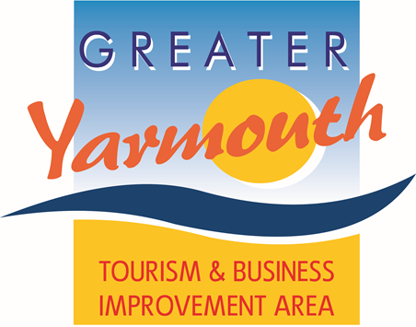 | Greater Yarmouth Tourism & Business Improvement Area Ltd
 |  | 1st October 2015 to 30th September 2016
 |  | 20th November 2015 |  | 28th January 2016 |  | 2nd March 2016
1 | Bid Levy | £ 480,000 |  | £ 490,000 |  | £ 490,000
2 | Maritime Festival | £ 90,000 |  | £ 90,000 |  | £ 67,200
3 | Income: |  | £ 570,000 |  | £ 580,000 |  | £ 557,200
4
5 | Priority Small Projects (15% = £60,000)
6 | Visit Norfolk | £ 8,000 |  | £ 8,000 |  | £ 8,000
7 | UK Beach Volleyball |  |  | £ 4,500 |  | £ 4,500
8 | Regatta Gorleston 2016 |  |  | £ 7,920 |  | £ 7,920
9 | GY Wheels Festival |  |  | £ 5,950 |  | £ 5,950
10 | Gorleston Cliff Fireworks |  |  | £ 2,000 |  | £ 2,000
11 | GY Arts Festival |  |  | £ 8,375 |  | £ 8,375
12 | Brush With the Broads |  |  | £ 4,250 |  | £ 4,250
13 | GY Film Festival |  |  | £ 8,000 |  | £ 8,000
14 | Martham Scarecrow |  |  | £ 500 |  | £ 500
15 | Hopton (10th) Fete |  |  | £ 2,032 |  | £ 2,032
16 | PSNGY |  |  |  |  | £ 500
17 |  |  | £ 8,000 |  | £ 51,527 |  | £ 52,027
18 | Priority Marketing (min £86,667 max £173,333)
19 | Marketing |  |  | £ 166,000 |  | £ 166,000
20 | Hemsby Prom Leaflet |  |  | £ 3,000 |  | £ 3,000
21 |  |  | £ - |  | £ 169,000 |  | £ 169,000
22 | Priority Events ( min £86,667 max £133,333)
23 | 2016 Fireworks | £ 25,755 |  | £ 25,755 |  | £ 25,755
24 | Gorleston Switch On | £ 9,300 |  | £ 9,300 |  | £ 9,300
25 | Maritime attractions | £ 25,000 |  | £ 25,000 |  | £ 15,000
26 | Hemsby Fireworks | £ 12,200 |  | £ 12,200 |  | £ 12,200
27 | Tempest NNF |  |  |  |  | £ 10,000
28 | Airshow 2017 |  |  | £ 22,200 |  | £ 22,200
29 | Eating Out Week |  |  | £ 18,400 |  | £ 8,400
30 |  |  | £ 72,255 |  | £ 112,855 |  | £ 102,855
31
32 | Marketing & Events Total |  | £ 80,255 |  | £ 333,382 |  | £ 323,882
33
34 | Facilities, maintenance & Access (max £80,000)
35 | Seafront Illuminations | £ 13,000 |  | £ 13,000 |  | £ 13,000
36 | Footfall Monitoring | £ 4,250 |  | £ 4,250 |  | £ 4,250
37 | Parking Discount Scheme |  |  | £ 20,000 |  | £ 20,000
38 | Station Welcome Hosts |  |  | £ 4,500 |  | £ 4,500
39 | Filby in Bloom |  |  | £ 3,000 |  | £ 3,000
40 | Winterton maps etc |  |  | £ 2,860 |  | £ 2,860
41 | Access Gateways |  |  | £ 12,000 |  | £ 7,000
42 | Gorleston Ivy Lodge |  |  | £ 5,000 |  | £ 5,000
43 | Hemsby Hanging Baskets |  |  | £ 3,290 |  | £ 3,290
44 | CCTV |  |  | £ 5,000 |  | £ 5,000
45 | Scratby Brown Signs |  |  | £ 3,000 |  | £ 3,000
46 | Vauxhall Bridge |  |  |  |  | £ 5,000
47 |  |  | £ 17,250 |  | £ 75,900 |  | £ 75,900
48
49 | Maritime Costs |  | £ 90,000 |  | £ 90,000 |  | £ 68,500
50 | Overheads |  | £ 80,800 |  | £ 70,800 |  | £ 80,250
51 | Contingency |  |  |  | £ 10,000 |  | £ 10,000
52 | Expenditure: |  | £ 268,305 |  | £ 580,082 |  | £ 558,532
53
54 | Surplus/Deficit |  | £ 301,695 |  | -£ 82 |  | -£ 1,332

