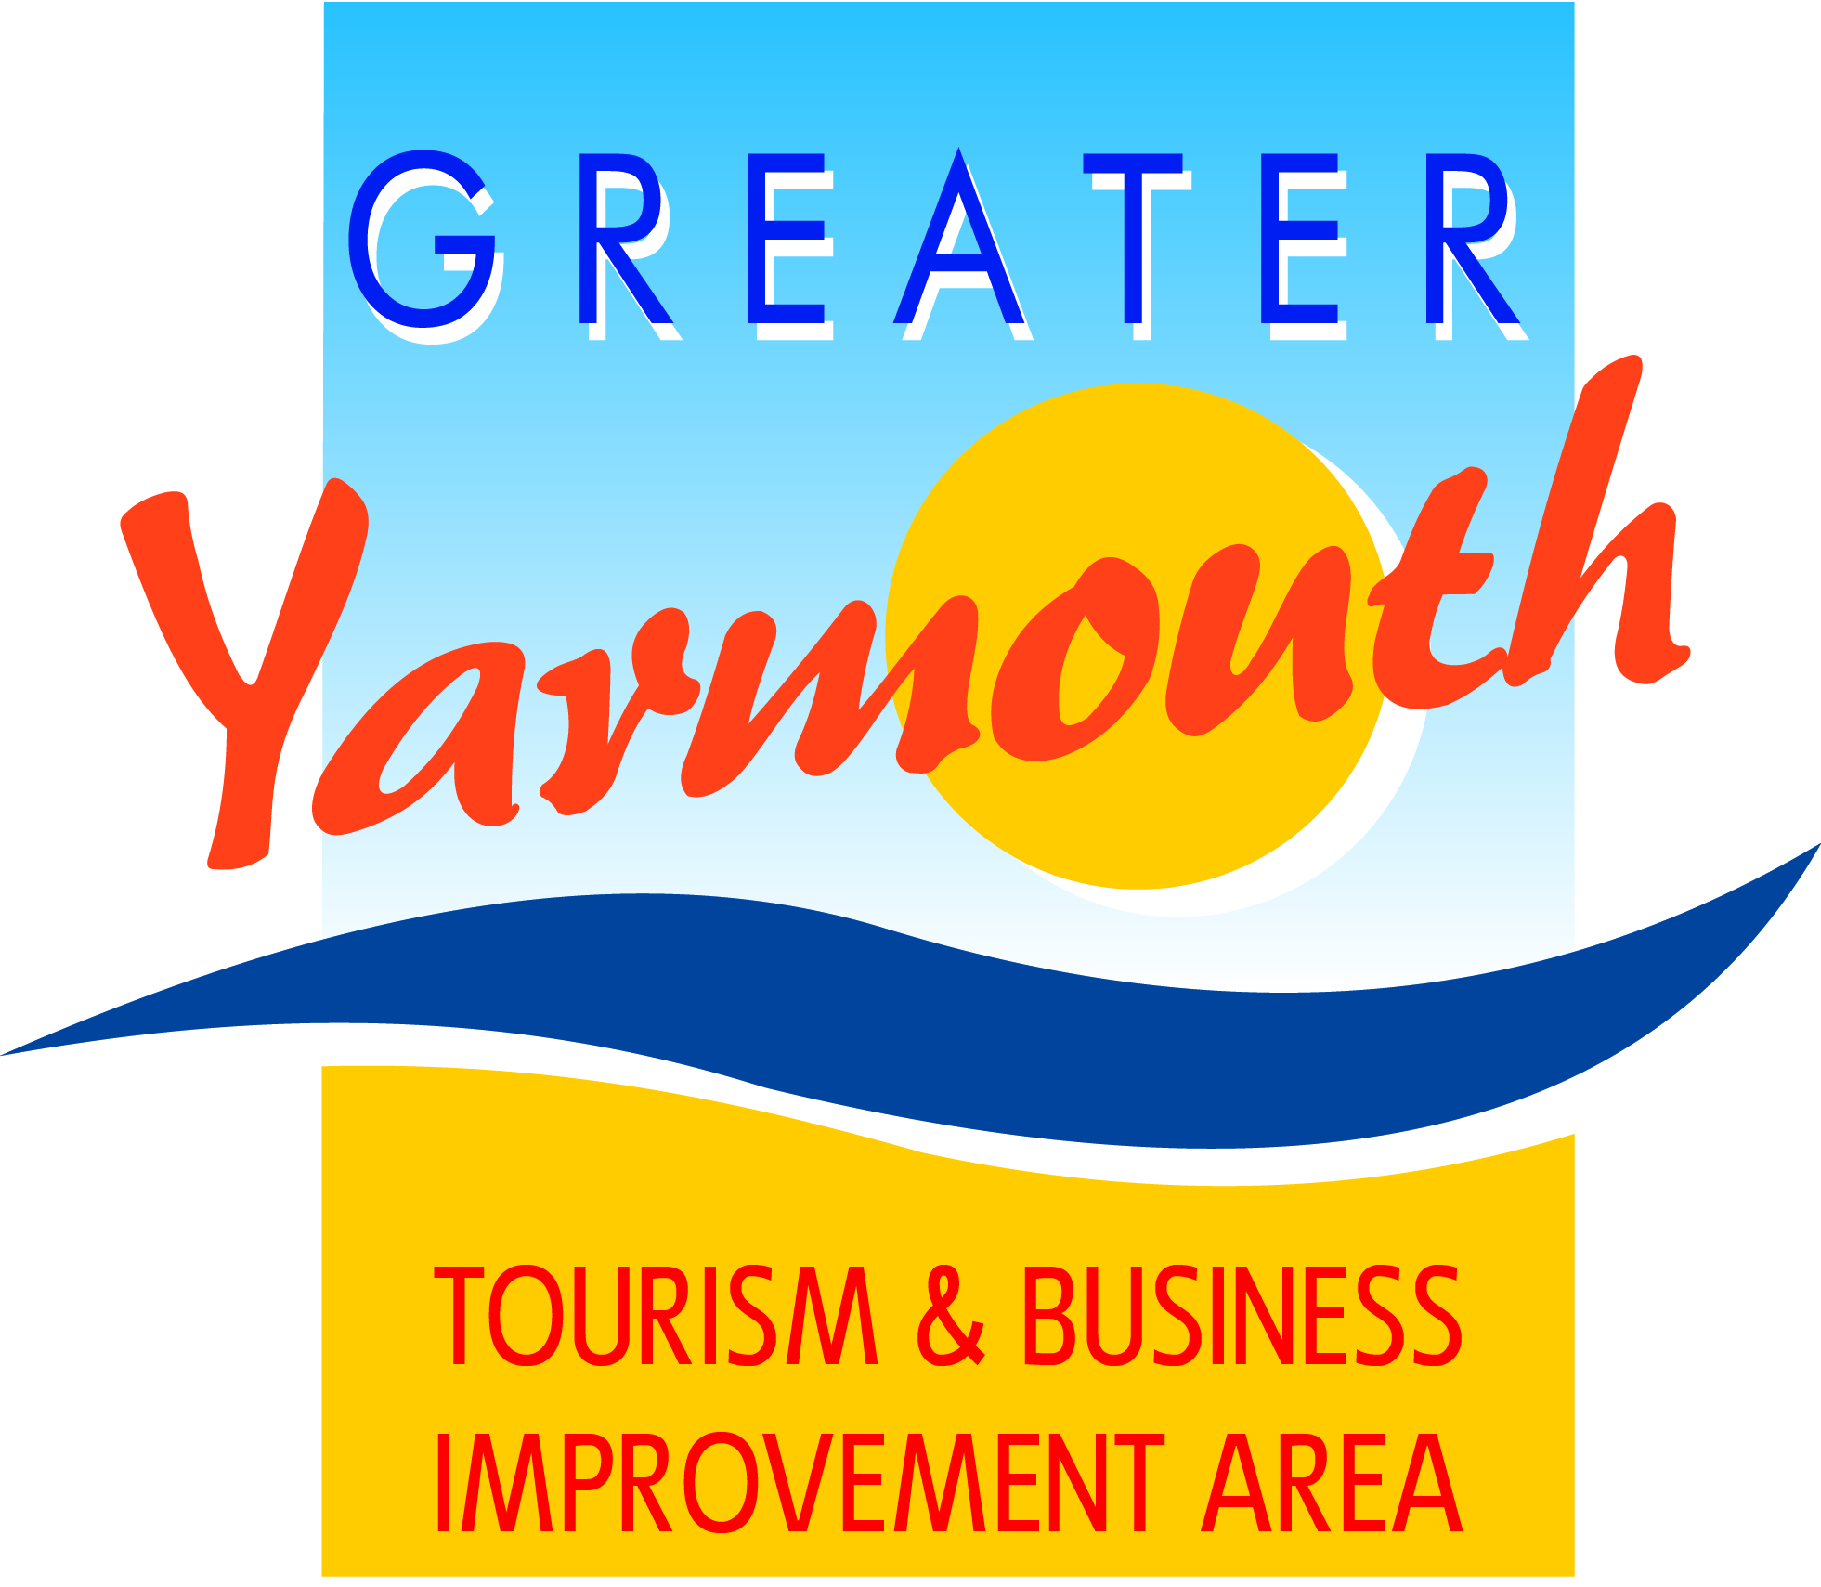
Minutes of the meeting of the
BOARD of the GREATER YARMOUTH TOURISM AND BUSINESS IMPROVEMENT AREA LTD
held on Thursday 15th September 2016 at Maritime House

Present
 | Gareth Brown (Chairman) | March 2020 |  |  | Tony Reeve | March 2017
 | David Marsh (Retiring Chairman) | March 2018 |  |  | Steve Cozens | March 2017
 | Peter Jay | March 2018 |  |  | Charles Reynolds | March 2017
 | Amy Woodyatt | March 2018 |  |  | Lyndon Bevan | March 2017
 | Albert Jones | March 2018 |  |  | Vacant Position | March 2017
 | Jane Reynolds | March 2018 |  |  | Margaret Farrow | March 2017
 | Kevin Huggins | March 2018 |  |  | Ken Sims | March 2017
 | James Grey | March 2018 |  |  | Gregg Haddon | March 2017
 | John Potter | March 2018 |  |  | Terri Harris | March 2017
 | Oliver Hurren | March 2018 |  |  | Vacant Position | March 2017

 | Councillors |  |  | Officials
 | Cllr Barry Coleman; GYTABIA Vice Chairman and Chairman of GYBC Econ Dev. |  |  | Alan Carr (GYTABIA CEO)
 | Cllr Paul Hammond |  |  | Karen Youngs (GYTABIA Project Management)
 | Cllr Demetrius Mavroudis |  |  | Kirsty Burn (GYBC Marketing)
 | Cllr Michael Jeal |  |  | Asa Morrison (Air Show Director)

1. |  | APOLOGIES FOR ABSENCE
 | 1.1 | Apologies were received from Karen Youngs, Ian Hacon.
 | 1.2 | Members noted that Andrew Bowyer has now left the Board.
2. |  | DECLARATIONS OF INTEREST
 | 2.1 | No declarations of interest were recorded.
3. |  | MINUTES OF THE PREVIOUS MEETINGS
 | 3.1 | It was recorded that the minutes of the BID Board meeting on 26th May were approved as a true and accurate record.
4. |  | MATTERS ARISING FROM THE MINUTES
 | 4.1 | Ref 7.4 RWE Power – no further correspondence
 | 4.2 | Ref 7.5 Northern Trust. The CEO confirmed that the former Pontins site at Hemsby was removed from the valuation list by the Valuation Office on 1st April 2010 and is therefore not liable for Business Rates and hence not included in the BID levy.  It was agreed that we should seek clarification as to why the former Pontins Site was removed from the valuation list.
 | 4.3 | Ref 7.7 Study Visit. Itinerary circulated. 2 places still available. It was agreed that a formal toast would be made at the Gala Dinner to celebrate the life of former GYTABIA Board member Tony Smith
 | 4.4 | Ref 7.8 EnterpriseGY – we have a table of 10. Tickets £25 for Board members & guests. Friday 11th November at 7.30pm.
 | 4.5 | Ref 8.2 Marketing/Webisodes – KB introduced and screened three new webisodes.
 | 4.6 | Ref 13.1 Seachange Out There: The CEO reported that GYTABIA had been awarded £70k by Arts Council England to stage ‘Upfront’ as part of the Out There Festival. The Joint Launch Reception at the Drill House 5pm-6.30pm on Friday - Board members welcome.
 | 4.7 | Ref 15.1 Board elections. DM reminded Board members that they had the mandate to co-opt Board members to fill the two vacant places.
5. |  | LEVY COLLECTION UPDATE
 |  | DM reported on that over the first 2 years of the BID the total billing was £954k (Yr1 £480k ; Yr2 £474k) As of the 1st August £915k had been collected representing a 96% collection rate. Around £5,000 of debts had been written-off, largely due to business winding-up. The outstanding £35k is currently being pursued through the normal legal process.
6. |  | FINANCIAL AND COMPANY ISSUES
 | 6.1 | Budget
 |  | Statement of accounts 1st October 2015 – 30th September 2016 were presented by the Company Secretary as attached (Appendix 1)
 | 6.2 | Constitution
 |  | No matters arising
 | 6.3 | Service Level Agreement with GYBC
 | 6.3.1 | Members were reminded that the Service Level Agreement with the Borough Council had yet to be signed pending further clarification on VAT implications. DM believed that these VAT issues had been resolved following discussions with the GYBC Finance Officer and with the VAT inspector.
 | 6.3.1 | The BID Management Team were still considering three options: (i) GYTABIA pay fee to GYBC to recognise the support of GYBC staff; (ii) GYBC waive any fee recognising that the work undertaken through the BID partnership is an extension of the work undertaken by GYBC staff and in line with the Council’s own economic objectives; (iii) GYTABIA sever links with GYBC and appoint their own staff.
7. |  | 2016 PROJECT UPDATES
 |  | The CEO circulated a summary sheet (Appendix 2) illustrating progress using the ‘traffic light’ system. Members noted:
 | 7.1 | Red Labels – withdrawn or deferred
 |  | PSNGY – withdrawn
 |  | Eating Out Week -
 |  | Station Welcome Hosts
 |  | Access Gateways
 |  | Vauxhall Bridge – awaiting match-funding decisions
 | 7.2 | Yellow Labels - work in progress
 |  | All to be completed by 30th September
 | 7.3 | Green Labels – completed
 | 7.3.1 | 2016 GY Fireworks – reported on the exceptional high attendance at the final 2 weeks of the GY Fireworks
 | 7.3.2 | 2016 Hemsby Fireworks – James Grey reported on a successful season of displays with good weather conditions.
 | 7.3.3 | 2016 Maritime Festival – the CEO reported that Saturday’s attendance were seriously affected by the forecast of bad weather (which never materialised) whilst Sundays attendances were the highest for 6 years.  Whilst voluntary contributions were slightly down on the £16,000 target this was more than compensated by the income from admissions to the Earl of Pembroke and the Esvagt Njord.  It was agreed to send a note of thanks and congratulations to Aileen Mobbs and the voluntary committee
 | 7.3.4 | Footfall Monitors
CEO reported on early results from the Regent Road footfall camera.
The RR camera recorded over 2.6 million people movements during 1st January – 31st August; over 50% being recorded in the last 8 weeks.
Highest week was w/c 22 Aug with 183,880 people movements – with 32,439 people moments captured on B/H Sunday.
8. |  | KEY PROJECTS 2017
 | 8.1 | Great Yarmouth Fireworks
 |  | It was noted the plans to stage 7 displays in 2017 dates: 19th, 26th July & 2nd, 9th, 16th, 23rd & 30th August
 | 8.2 | Hemsby Fireworks; It was agreed to fund 7 displays (dates to be confirmed)
 | 8.3 | Maritime Festival – to be held over the weekend of 9th & 10th September 2017.
 | 8.4 | Air Show
 | 8.4.1 | Financial Report by the Finance Director
 |  | DM circulated a financial summary (Appendix 3)
 |  | DM explained that the spreadsheet illustrated ‘best-case’ and ‘worst-case’ budgeting and that it would be prudent to budget for an over cautious budget which could be adjusted accordingly rather than an over-optimistic option.
 |  | It was hoped that as income potentials were realised then budgets could be adjusted putting money back into the general fund for other projects
 | 8.4.2 | Report update by the Event Director
 |  | The Event Director responded to queries raised by members including:-
-Discussions were already taking place with potential media partners but it was anticipated that the marketing plan would be discussed and determined by the GYTABIA Marketing Group.
-The dates chosen now only clashed with Weston super mare; the Biggin Hill show and the Cosforth show had now moved dates.
-Plans were in hand for a cycle park
-Traders will be advised that essential deliveries will be restricted to early morning.
-We were working with a nationally recognised traffic management company to ensure that robust systems are in place.
 | 8.4.3 | Written Report by the Sponsorship Director
 |  | -DM summarised a written report prepared by Ian Hacon, the Air Show Sponsorship Director, highlighting:-
-Directors were advised that Ian had already achieved 77.5% of the £100,000 target and work was still on-going to secure further sponsors,
1 x title sponsor
3 x Platinum sponsors
1 x Gold sponsor
-Future would concentrate on gaining signed contracts; satisfying the likely strong demand for corporate tables; and active pursuant of key business sectors,
 |  | It was agreed to set a budget of £543,750 expenditure and £330,000 income and that all efforts would be made to increase the income in order to lower the net costs.
 |  | It was agreed that the Event Director would hold a separate briefing meeting – inviting all board members – to explain in more detail the Air Show operating plan.
 | 8.5 | Budget Setting Implications
 | 8.5.1 | DM circulated a summary budget sheet 2016-2017 for discussion (Appendix 4)
 | 8.5.2 | It was agreed that the following items would be confirmed as priority funded projects for 2016-2017:-  £26,500 Great Yarmouth fireworks  £9,300 Gorleston Switch-on  £15,000 Maritime attractions (as part of the Maritime Festival)  £13,000 Hemsby fireworks
 | 8.5.3 | The following items were also noted an contractual commitments  £13,000 Annual maintenance of decorative lighting  £4,250 Annual maintenance of footfall counters
9. |  | PROJECTS FOR DISCUSSION
 | 9.1 | Discount Car Parking Scheme – It was agreed to defer this item until next meeting
 | 9.2 | Update on future projects
 | 9.2.1 | Caister Proposals – noted that businesses in Caister were likely to be submitted an application for funding in the next round.
 | 9.2.2 | Pumpkinanza – It was agreed that £1500 be made available to support the October half-term fireworks display
10. |  | CONTRACTUAL PROJECTS
 | 10.1 | Decorative Lighting
 |  | It was noted that some columns had experienced periods of outage but were resolved quickly.
 |  | More issues with faulty Esplanade lighting and lack of beach lighting.
11. |  | APPLICATION TIMETABLE
CEO confirmed the application timetable as:-
4th October – circulation of Newsletter
21 October – closing date for receipt of project applications
w/c 31 October – BID Management Group strategic appraisals
10 November – BID Board
12. |  | MARKETING & COMMUNICATIONS
 | 12.1 | Members noted the increase in PR activity and social media activity.
 | 12.2 | KB circulated a brief summary of marketing activities attached at Appendix 5
13. |  | ANY OTHER BUSINESS
 | 13.1 | Members were asked to consider supporting the Borough Mayor (former GYTABIA Board member, Malcolm Bird) at his fund raising charity events
 |  | - 23 September @ Merrivale Model Village/Tea Room. Tickets £15
 |  | - 1 October @Town Hall Tickets £35/Black Tie
14. |  | DATE OF NEXT MEETING
 | 14.1 | It was agreed that the next meeting would be held on 10th November 2016 at 10am at Maritime House.

