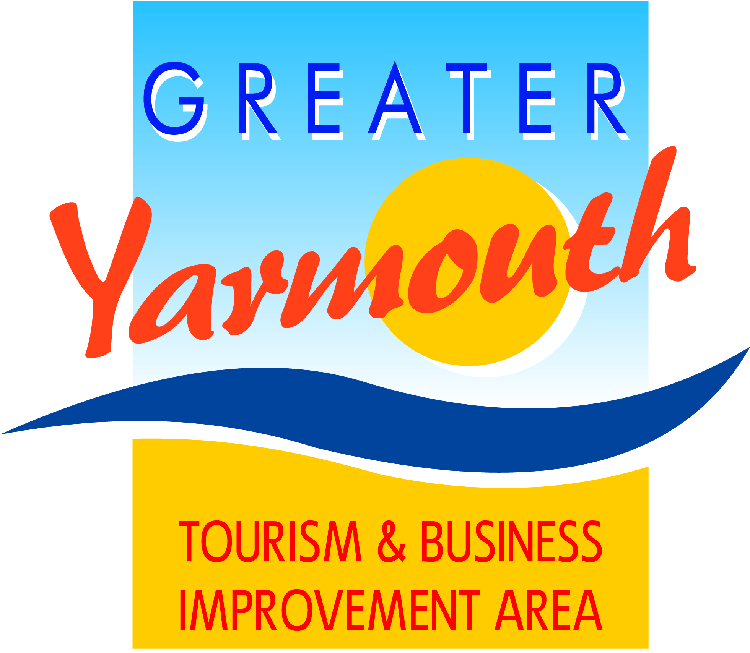
MINUTES of the SPECIAL MEETING
of the BID BOARD held on TUESDAY 13th DECEMBER 2016

Attendees
Gareth Brown, David Helsdon, Asa Morrison, Cllr Paul Hammond, Cllr Barry Coleman, Cllr Penny Carpenter, Terri Harris, Tony reeve, Ken sims, Olly Hurren, Kevin Huggins, Jonathon Newman, Darren cross, Charles Reynolds, Peter Jay, Alan Carr, David Marsh.

Apologies:
Lyndon Bevan, James Grey, Gregg Haddon. Albert Jones, Amy Greenwood.

- Introduction
  - Gareth Brown and David Marsh outlined the purpose of the meeting and the background and scope of preparations to stage the 2017 Air Show. It was noted that the 3 key RISK issues:
    - Presence of Little Terns on North Denes
    - Medical Provision
    - Traffic Management.
  - The Air Show Management Group were addressing all three issues as a priority.

- Health & Safety/Structure
  - Asa covered the preparation of the Event Management Plan, the evolving structure and the various risk Assessments.
  - The GYBC Officers and Members groups
  - The GY Event Safety Advisory Group.
  - Marine Safety
  - Flight display committee
  - Security & Stewarding.
  - Event delivery including gold-silver-bronze commands

- Marine Management – Asa reported the following points of information:-
  - The Coastguard main lead.
  - Safety boats/Managing the river/ viewing spots.
  - Breydon Water noted as potential drop anchor viewing point – patrols will be on hand to move people on.

- Traffic/Crowd Management: noted
  - Estimated 200-300k visitor; 3 or 4 times more than GYs busiest day.
  - Management Board appointed of Mervyn Lambert as traffic managers
  - All park & ride sites aim to be within 20 minutes travel times.
  - Option to re-think the Acle Straight. One-way mid-late evening.
  - Next meeting early January with NCC and Highways England.
  - Closure of Marine Parade from cinema to main cross road (Sterile Zone).
  - Pedestrian routes
    - Expect via main routes to be via Hall Quay & Regent Road/St Georges Park.
    - Nelson Road/Regent Road will need to be a managed crossing point.
    - Gorleston cliffs/beach – inevitably the cliffs/beach will be seen by many as a decent viewing point .
  - Answers to Questions:
    - 10,000 spaces required/could be spike on Red Arrows days.
    - Park & Ride sites predominantly to the North and South with an overflow at the Rugby Club.
    - Aim to get Park & Ride sales on line by 1st March
    - Agreed to investigate a temporary footbridge over the outer harbour.
    - Noted that managing parking in residential areas is being handled by traffic managers. Agreed residents need plenty of warning to plan ahead.
    - No current plans for commercial trade stands in Gorleston – priority is to get people to park in designated P&R sites:.
    - Agreed that schools will need to be advised about likely travel disruption so that schools and teachers can plan ahead.
    - Mervyn Lambert would be assessing usage of town centre car parks:
    - Agreed to considered - Beaconsfield; Wellesley and High School as potential parking sites being mindful that fewer larger sites are more economic to run than several smaller sites.

- Trade Sites - noted
  - Trade stands would be mainly between the cinema and the Sea Life Centre
  - BID members already received trade packs.
  - Prices start from £450 for a 3m x 3m for 4 days.
  - Ice cream (4) and bars (4) would be subject to formal tender.

- Site Management
  - David Helsdon (Site Manager) summarised issues/work
  - Marine Parade closure would be gated and road blocked

- Sponsorship
  - £100k sponsorship target still on course.
  - £100 a head hospitality.

- Any Other Business.
  - Answers to Questions:
    - The chairman confirmed that appropriate Insurance cover would be in place
    - Car Parks would cater for the required disabled bays?
    - GYBC had granted permission for the Air Show to host a Charity Village on the green at the Marine Parade end of Trafalgar Road.

