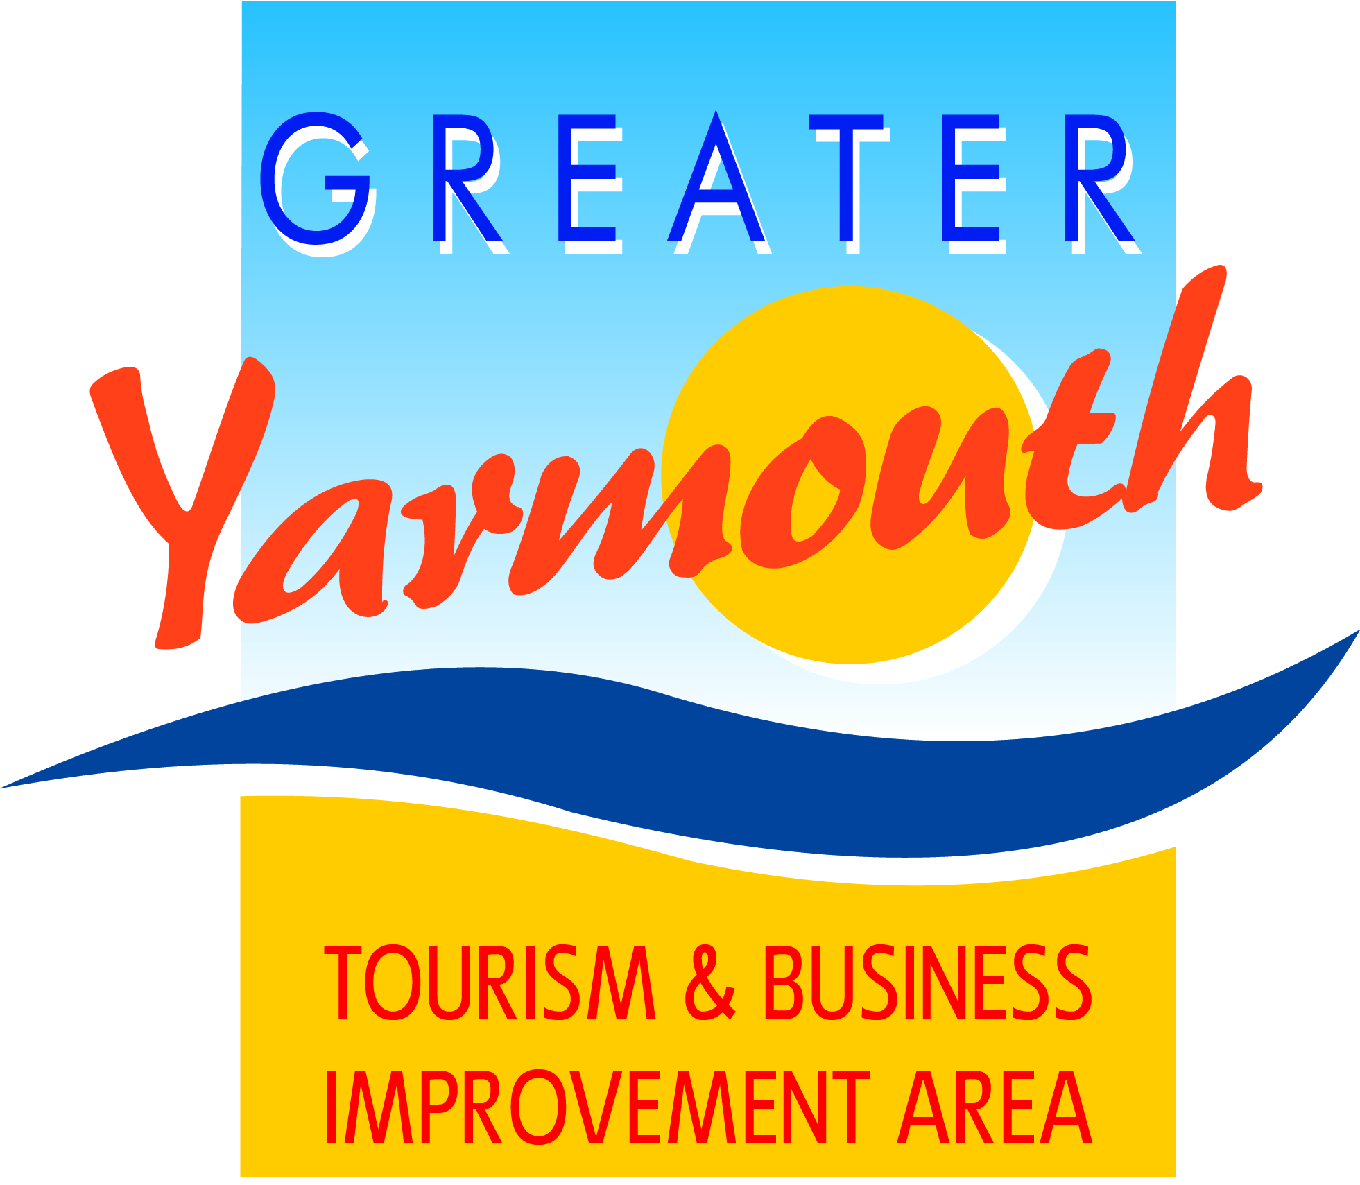
Minutes of the special meeting of the
BOARD of the GREATER YARMOUTH TOURISM
AND BUSINESS IMPROVEMENT AREA LTD
held on Tuesday 31st January 2017 at Maritime House

Present
 | Gareth Brown (GB) (Chairman) | March 2020 |  |  | Tony Reeve (TR) | March 2017
 | David Marsh (DM) (Retiring Chairman) | March 2018 |  |  | Steve Cozens (SC) | March 2017
 | Peter Jay (PJ) | March 2018 |  |  | Charles Reynolds (CJR) | March 2017
A | Amy Greenwood (AG) | March 2018 |  |  | Lyndon Bevan (LB) | March 2017
 | Albert Jones (AJ) | March 2018 |  |  | Vacant Position | March 2017
 | Jane Reynolds (JR) | March 2018 |  |  | Margaret Farrow (MF) | March 2017
 | Kevin Huggins (KH) | March 2018 |  | A | Ken Sims (KS) | March 2017
 | James Grey (JG) | March 2018 |  |  | Gregg Haddon (GH) | March 2017
 | John Potter (JP) | March 2018 |  |  | Terri Harris (TH) | March 2017
 | Oliver Hurren (OH) | March 2018 |  |  | Vacant Position | March 2017
*A = Apologies
 | Councillors |  |  | Officials
 | Cllr Barry Coleman; (BC)  GYTABIA Vice Chairman and Chairman of GYBC Econ Dev. |  |  | Alan Carr (AC)  (GYTABIA CEO)
 | Cllr Paul Hammond (PH) |  |  | Karen Youngs (KY)  (GYTABIA Project Management)
 | Cllr Demetrius Mavroudis (DMv) |  |  | Kirsty Burn (KB) (GYBC Marketing)
 | Cllr Michael Jeal (MJ) |  |  | Asa Morrison (AM) (Air Show Director)*
*for the Air Show item

1. |  | Apologies For Absence
 |  | Apologies were received from Amy Greenwood, Ken Sims.
2 |  | Declaration Of Interest
3. |  | Minutes & Matters Arising From The Previous Meeting 10 Nov 2016
4. |  | Financial And Company Issues
 | 4.1 | Levy Collection Update
 | 4.2 | Financial Report
 | 4.3 | Annual Tourism & Business Awards
 | 4.4 | Meetings Programme 2017
 | 4.5 | Co-opted non-voting board members
5. |  | Air Show 2017
 | 5.1 | Operational Issues
 | 5.2 | Revised Budget
6. |  | Small Projects – Scoring Appraisal
 | 6.1 | To finalise the budget allocation to small projects
7. |  | Any Other Business
 | 7.1 | Market Place project
9. |  | Date Of Next Meeting

Appendix C
Marketing - these projects have been prioritised by the Marketing Working Group
13 | PR | £14,000
14 | Radio/Weather campaign | £28,000
15 | On-Line Promotions | £10,000
16 | 2-hr drive Essex/N.London (pre-Easter) | £0
17 | 2-hr drive Essex/N.London (April) | £16,000
18 | 2-hr drive Essex/N.London (May) | £16,000
19 | 2-hr drive Essex/N.London (June) | £16,000
20 | 2-hr drive Essex/N.London (Sept/Oct) | £16,000
21 | 1-2 hour drive | £15,000
22 | Research | £10,000
23 | Social Media/Facebook | £5,000
24 | On Line Adword - Pay Per Click | £5,000
25 | TV Production | £15,000
26 | Retargeting & prospecting | £5,000
27 | Visit Norfolk | £3,800
 |  | £174,800

Small projects - projects less than £10,000 – to be prioritised by the Board.
28 | Hemsby Hanging Baskets | £3,430
29 | Filby in Bloom | £3,400
30 | GY Wheels Festival | £6,000
31 | Feastival/Eating Out Week | £5,000
32 | Hemsby Beach Cleaning | £4,900
33 | UK Beach Volleyball | £6,200
34 | Fritton Village Sign | £4,000
35 | Gorleston Cliff Top Fireworks | £3,500
36 | Caister Village Experience | £2,000
37 | Hemsby Toilets | £1,175
38 | Martham Scarecrow | £650
39 | Brush With the Broads | -
40 | GY Film Festival | -
 |  | £40,255

